A CELEBRATION OF THE LIFE OF
ANNE MARGARET ROBERTS

5th October 1946 – 19th April 2019

held at
The George Hotel, Wallingford
on 7th May 2019

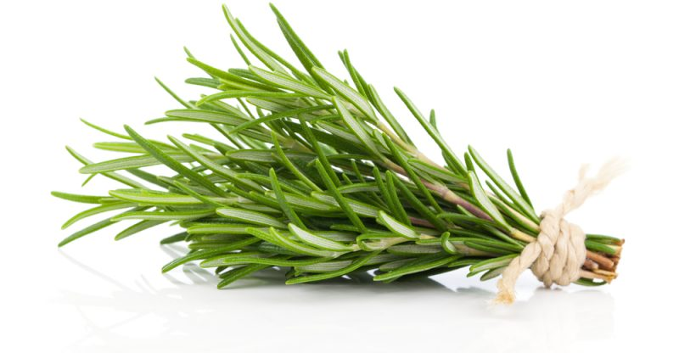

Humanist Celebrant
Ian Willox
01865 589 663
ian.willox@humanistceremonies.org.uk

Humanists UK
39 Moreland Street, London, EC1V 8BB
020 7324 3060
www.humanism.org.uk

TRIBUTE
I never met Anne. So I’m relying on what Gareth has told me and written for me, and on a wonderfully detailed timeline that Anne herself compiled. More of that later..

Here’s what Gareth wrote:

Anne sadly passed away peacefully in her sleep at about 8.30pm on 19th April at the Ostler Chest Ward of the John Radcliffe Hospital. Her husband Gareth was at her bedside when it happened. The cause of death was pneumonia in conjunction with severe pulmonary fibrosis.

The first sign that she was not well emerged on Christmas Eve 2017 when she began coughing severely whilst on holiday in Lanzarote. This carried on through the night and was so bad on Christmas morning that an ambulance was called and she spent six hours in the hospital at Arrecife. It was found that she had a chest infection. This led to a reduced lung capacity which restricted her movements.

Since then her condition has gradually deteriorated in spite of several visits to the lung clinic at the Churchill where a number of treatments were tried unsuccessfully to alleviate the problem. This became so serious that for the last few months she has been on oxygen twenty-four hours a day.

She was admitted to the JR in December after experiencing severe breathlessness in the morning despite the oxygen. The following Wednesday both Gareth and her son Richard were summoned to the hospital where the doctor informed them that her condition was serious and the only option was to increase her intake of steroids and antibiotics. The whole family were at Anne’s bedside on Thursday and Friday but sadly she didn’t pull through.

Anne was born on 5th October 1946 in Middleborough, North Yorkshire. She attended school there and at Our Lady’s Convent in Abingdon.

She was first married in 1965 and Richard was born in July 1969. She started working at the Atlas Laboratory in 1970 and then for the Natural Environment Research Council in 1978. After parting ways with Richard’s Dad she got engaged to Gareth in 1974. They married in September 1975.

Richard married Kylie in September 1994. Chloe, Anne’s first granddaughter was born in January 1996. Her second, Jordan, was born in April 1999.

Anne took early retirement in 1998. Gareth retired on the same day.

Not one just to put her feet up, she became a driver for the Wallingford Volunteer Centre mainly driving elderly local residents to appointments at Oxford or Reading hospitals which she did until 2011

Still not wanting to hang her hat up just yet she worked as a carer for ‘Styleacre’ looking after young adults with physical or mental disabilities. This proved fascinating to Anne as it showed her that these vulnerable people could have a decent life as long as people were willing to put the effort into helping them. She did this for almost four years before finally ‘officially’ retiring almost 17 years after her ‘unofficial’ retirement!

This official retirement was not without its challenges. She underwent two hip replacements, one knee replacement and a minor heart procedure to correct a faulty nerve that she was proud to claim was the same condition Tony Blair had just been treated for. Anne recovered very quickly from these minor setbacks with her usual no fuss attitude.

Before her illness Anne was a very active person. She was a keen swimmer and would spend an hour most days swimming seriously.

She loved to travel and spent several holidays with Gareth in places as diverse as Australia, New Zealand, Kenya, the Caribbean, Thailand and Canada – as well as many holidays in Europe.

The place they most frequently visited was the west coast of Turkey. There was one unforgettable evening on the terrace of a restaurant overlooking Oludeniz listening to a recording of Luciano Pavarotti singing Nessun Dorma as the sun slowly sank into a valley on an offshore island. There’s a photograph of the moment in Gareth and Anne’s bedroom.

One of Anne’s travelling companions, ‘Sister Agnes,’ is here today, Agnes has been a family friend for over 30 years now. The pair of them would often pack their bags and set off to some foreign climes for a ‘bit of culture’ and the odd glass or two of dry sherry to wash away the toils of their sightseeing earlier that day. Anne would often reminisce about these adventures and spent many happy hours researching their next trip across the globe.

She documented almost her entire life highlighting some 200 events in a timeline that is available to read through on the table over there. indicate

Anne used to like playing tennis and in 1987 joined a group of like minded ladies. The group is still going strong – though they now restrict their activities to meeting on the evening of the first Friday of each month for food, drink and a natter. They also take a short break together every year. The hope is that these activities will continue in the same spirit. It’s what Anne would have wanted.

Anne was very interested in Egyptology. She was an active member of the Thames Valley Egyptology Society. This involved attending conferences, presenting papers, visiting museums and several visits to Egypt. Anne even had some of her work published in relevant monthly publications.

As we’ve already mentioned, one of Anne’s greatest pastimes was ‘planning’ - be it yet another holiday, the next Tennis Ladies ‘do’ or organising a trip for her and friends in the Ancient Egyptian society to museums across the UK and Europe to see unusual artefacts from across the world.

Her most successful pleasure was to ensure her two granddaughters would not only grow up to be nice young ladies but to become successful, well educated and well travelled adults.

She encouraged the girls to learn to swim at a very young age. Chloe went onto to represent the Wallingford Air Cadets in a regional swimming competition.

Jordan was approached to join a local swimming team because she showed great potential as a fast swimmer. Jordan didn’t take up this offer but decided to play football for the Cholsey Blue Birds instead and gave the boys in her and opposing team a good run for their money. Now they are both adults they still have a natural affinity with the water.

When Chloe and Jordan were old enough, Anne and Gareth took them on lots of foreign holidays. There were several memorable events including zip trekking in Antigua, scuba diving in the Red Sea and Tenerife and, best of all, snorkelling with dolphins in Egypt.

A recent highlight of Anne’s life happened in February of this year when Chloe graduated with an upper second degree in nursing at Northampton University. She is now happily employed at the children’s hospital in Milton Keynes as a children’s nurse

Meanwhile Jordan is studying molecular biochemistry at Bristol University and expects to graduate next year. It is a shame that Ann will not be here to attend her much anticipated graduation ceremony.

Both Chloe and Jordan owe and recognise so much of Anne’s encouragement and we all hope they live life to the full as their grandmother truly did.

Anne was an honest, positive and happy person who was respected by everybody who knew her. She will be sorely missed.

Gareth’s tribute to his wife.

