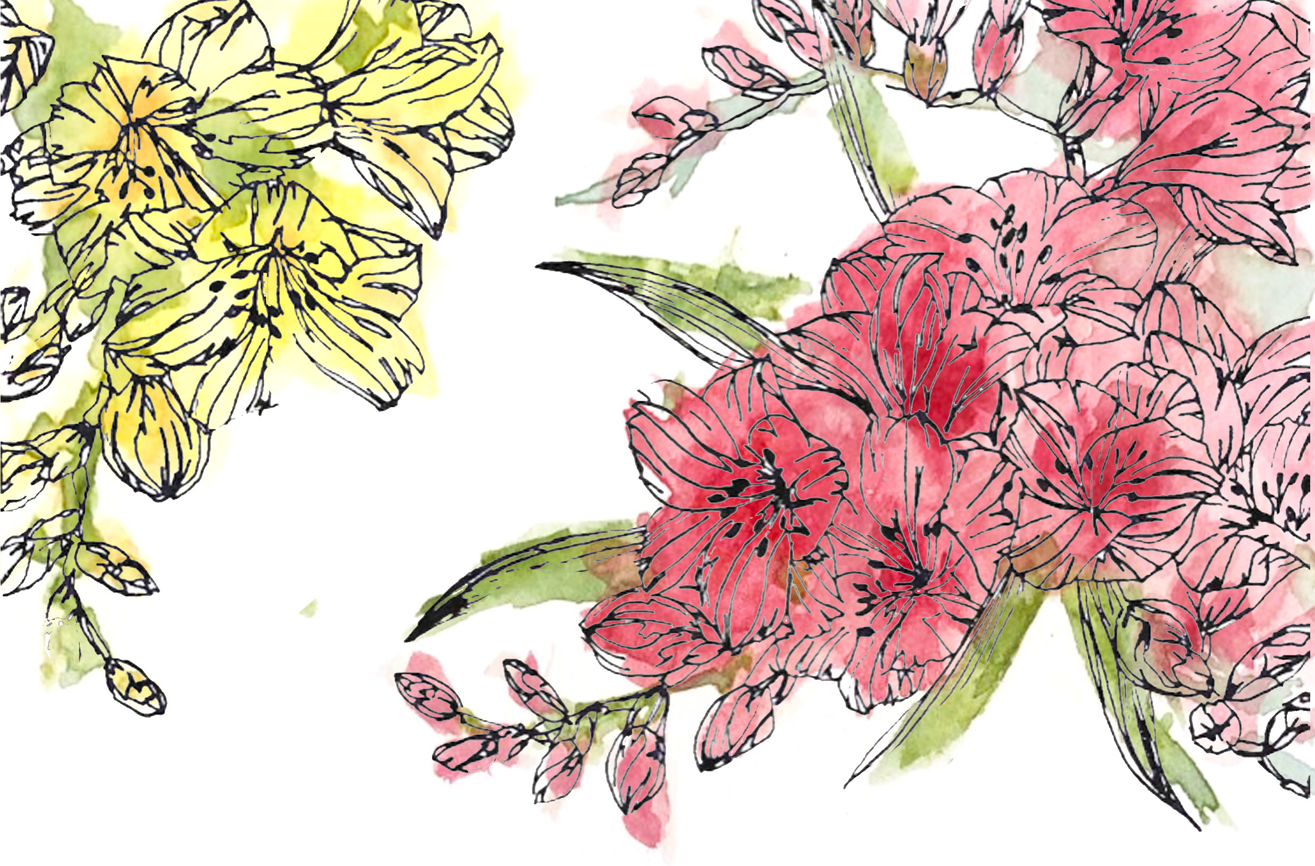

A celebration of the life of

Audrey Goodwin

27th June 1925 - 14th April 2019

Main Chapel, Langney Crematorium Eastbourne
May 10th, 2.30pm

Celebrant: Felicity Harvest, accredited by
felicity.harvest@humanistceremonies.org.uk
01892 783226 07708 933607

The Tribute

Audrey was born in 1925, the same year as several other formidable women, including Laura Ashley, Margaret Thatcher, and June Whitfield.

She was the middle child of George and Dora Vail, and she spent the first part of her childhood in a lovely Victorian house near the Thames in Teddington, and had fond memories of walking the dogs in Bushey Park. George was one of three brothers who owned and ran a successful building merchants in East Sheen, Middlesex. During the war, her elder brother Brian went into the RAF, and the rest of the family moved to Cheltenham.

After the war, the three brothers Vail went their own ways and George ended up running the family firm. This led to further changes, and during these years she spent what she described as very happy times, living in a flat with her parents overlooking the builders yard in East Sheen. She liked the bustle of the place, and the constant comings and goings, but soon she was off herself to make her own way in the world, moving to Guildford - first as a librarian, then a telephonist and finally to study to be a nurse. She was very proud to have the respected qualification of a “state registered nurse”.

During her early nursing years, she worked as a theatre sister assisting on the first skin grafts in the country and she was allowed by the surgeons to “stitch up wounds” , precipitating a life long love of needle work!

There, on the party scene, she met a suave army officer and gentleman also from Teddington, Tony Goodwin (also known as “Sam” after the popular character “sporting Sam”). They shared a love of culture, particularly amateur dramatics, and of competitive sport. They were married on 23rd December 1950.

Moving for Tony’s work as a chemical engineer, they went first to Southam in Warwickshire, where Joanna and Paul were born, then to Royal Leamington Spa, and finally to Carshalton in Surrey, where they stayed for many years, and where they brought up their family.

Here Audrey started her long love affair with gardens, plants, sunshine and “keep fit with Eileen Fowler”, a precursor of the Jane Fonda work out in the local church hall, with mass gatherings in London and elsewhere. No lycra then though !

Audrey kept on nursing even when Jo and Paul were young, working part time at the local cottage hospital when they lived in Surrey. Never one to be idle, she became an Avon Lady, and a market tester for the chocolate company Cadbury - much to the delight of Paul and Jo. This entailed visiting local families with boxes of plainly wrapped chocolate sweet samples to get feedback on new products. Inevitably there were always a few uneaten samples left at the end of the day. The Goodwin household was always a popular place.

A move to leafy Kingswood in Surrey resulted in Tony encouraging Audrey to take up golf. When they moved to Bexhill on Tony’s retirement Audrey started playing increasingly competitively, becoming Lady Captain at Highwoods for a period. Though they rarely played in matches together, and she would not have admitted it, it was clear to most that she was the better player!

Next on Audrey’s list of sports was competitive bowls at two Bexhill clubs, Edgerton Park and Gullivers, where she also supported Tony in fighting for the survival of the club. Never one to conform, it was evident that the white “porkpie” hats that were required uniform for ladies in bowls matches were not to her liking.

She was always fiercely competitive, even right at the end of her life when in her wonderful care home in Woodbridge she played indoor putting, long games of Gin Rummy and even a little Poker!

Already an accomplished amateur artist, Audrey was inspired by a local Bexhill painting teacher to take up Chinese painting. In her 70’s, she had a memorable trip to China where she studied with a Chinese master, coming back to England with a new set of skills, and creating some beautiful works.

In the years she lived in Bexhill she made many friends and was much loved in the community. She became passionately involved in the local Macmillan Cancer fund activities. She lived a rich life, enjoying Art at the De La Warr Pavilion, and theatre and musicals, underscoring a life long love of music. She enjoyed hosting friends, and loved drinks and ‘nibbles’ playing bridge with friends with a glass or two of wine to help things along.

She was throughout her life an amazing cook. Paul says: “In my household her apple pie, chocolate cake and cheesy spaghetti will be sorely missed, and I have tried to continue her legacy in my own cooking style!”

Paul will now read a message sent by Tom, who is in Bali so couldn’t be here today. You’ll notice that chocolate cake features in the message.

Grandma,

I’m sitting here writing this overlooking still Thai waters and a stunning golden sunset shining effortlessly on the deep blue waters, a scene not far from your beautiful paintings, but a scene that could not remind me more of you.
Words could not describe you or your endless wisdom, warmth and true warriorship for life,
Your determination to help, humour and bake the finest chocolate cakes are a mere few of the traits that made you the gorgeous human that you always shall be,
From your never ageing elegant smile to your deep nursing care that you forever had for us and the world around,
Thanks for never showing a frown to make positivity a must,
Thanks for everything you gave us from your wit to your utter grit for life,
I will always remember our last goodbye and the never-dying spark you had in your eyes,
You are really an inspiration to all of us that whatever happens or whatever you may go through in life, with positivity and a smile you will always be fine, fine, fine.
Thank you so much Grandma, rest happy and free.

Audrey was a sun worshipper. She liked nothing better than sitting on the beach at Cooden with a picnic from Marie’s, or walking by the sea at Bexhill.
When Jo bought a convertible car, she used any excuse to travel with the roof down even in winter when scarf, woolly hat and the heater full on was the order of the day.

Though she was never one to complain or admit to increasing health problems, in 2017 the family together agreed that she should move to Suffolk to be closer to Jo, as Paul was frequently away for work.

She quickly found the sunny spots at Grove Court and at the hint of nice day she could be found with a book, sunglasses at the ready, in a sheltered spot or in the summer house looking out towards the river Deben. Although normally a fast reader, it was noticeable how few pages got turned, leading Jo and Paul to suspect snoozing was a much better option

As you know, Audrey loved gardening and had a vegetable patch at every house she lived in. It didn’t take her long to befriend the gardener at Grove Court and the two of them could often be found sitting admiring the rose bushes Audrey had been given as 90th birthday gifts and had brought with her from Fontwell Avenue, and plotting the planting in her courtyard garden for the coming year. She loved her lunches in Woodbridge’s pubs and restaurants – particularly tapas which suited her liking for “grazing” - and her half of bitter shandy or her delicious and naughty affagato. These trips were often with Jo, accompanied by Alan, her life partner, the essential and sympathetic supporter of the supporter.

Audrey had a generous and compassionate nature and quickly established herself as the Marjorie Proops agony aunt of the care home, giving the benefit of her 90 plus years of experience to staff young and old. Whether broken engagements, wedding dress choices, house moves or boyfriend troubles she was always on hand with straightforward no-nonsense advice. When visiting her room Jo would often find one of the nurses or care assistants sitting on the floor beside Audrey’s chair putting the world to rights. They were her extended family and they felt the same about her - she had that effect on people.

As Paul said: “Neither Jo nor I realised the extent to which she had become the staff agony aunt; always listening, being non judgemental, finding the special qualities and interests of her subjects, while getting them to open up and receive her sage advice.”

It was lovely that Audrey was able to live out the last years of her life at The Grove, where the staff were very caring and really loved this jolly, engaging, supportive, funny, creative and occasionally stubborn old lady!

In the end, at the age of nearly 94, she quietly faded away, looking out at her favourite roses, with some of her beautiful art work on the wall, having heard the voices and felt the hands of many of those who meant the most to her. Jo was at her side.

We often think of death as a cruel enemy, taking away those we love, but for those who are suffering or who have reached the end of their endurance, it can come as a quiet friend, closing the curtains, blowing out the light, and settling us into a last sleep, free from pain and weariness.

I hope it was so for Audrey.

