A HUMANIST FUNERAL CEREMONY

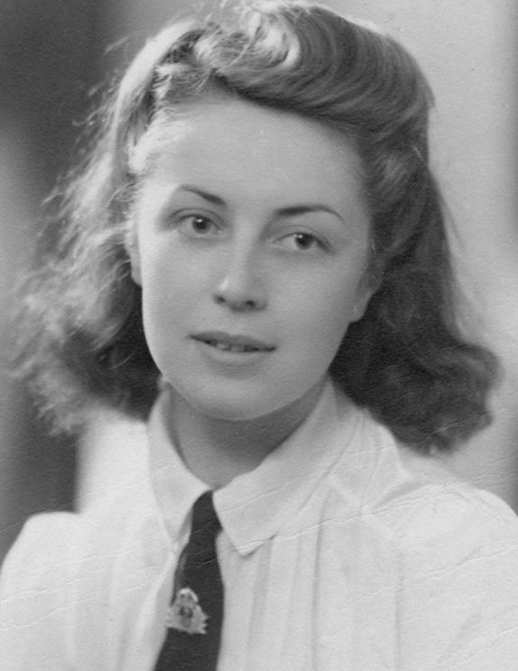

A CELEBRATION OF THE LIFE OF

CHRISTINE FINLOW

3rd February 1923 – 12th April 2018

TIXALL ROAD CREMATORIUM
STAFFORD

Thursday 3rd May 2018
3.00 p.m.

BHA Accredited Celebrant: Tag (Mary) McEntegart
52 Moseley Avenue, Coventry. CV6 1AB
Telephone: 0780 883 4471 e-mail: sisters6@pobox.com

Humanists UK, 39 Moreland Street, London EC1V 8BB
Telephone: 020 7324 3060 / E-mail: info@humanism.org
The British Humanist Association is a Registered Charity
A CELEBRATION OF THE LIFE OF
CHRISTINE FINLOW
3rd February 1923 to 12th April 2018

RHAPSODY IN BLUE: by George Gershwin:
Leonard Bernstein and the Chicago Symphony Orchestra

Opening words

As the notes of Gershwin’s ‘Rhapsody in Blue’ fade away, I’d like to welcome you all, on this spring day, to this commemoration and celebration of the life of Christine Finlow. It is an honour for me to be joining Jill, and the rest of her family and friends, to mourn and to celebrate Christine – both the person and her long life. I greatly appreciate being given the honour to lead this unique celebration of her. Through giving shape to your expression of your loss AND celebrating the impact that her long and good life had on your lives, we’ll hold the memory of your greatly loved mother, friend & neighbour with us for a while longer.

My name is Tag McEntegart, and I’m an accredited celebrant with Humanists UK. I know from Jill that Christine believed in someone who she prayed to and thanked, but that she didn’t, herself, participate in organised religion. Although she did help at church fetes and, when Jill was young, her mama did provide numerous meals for a hungry curate with 5 kids but that was because she was nice!

Taken in the round, Jill felt that it was more appropriate to celebrate Christine’s life with a personal and non-religious ceremony. Chris did appreciate, however, that many people do hold religious beliefs that mean a lot to them, and so time will be made later on for reflection and private prayer.

This commemoration values the humanist outlook that the human species is part of the beautiful natural world that is planet Earth. This is our home and our only home, death is the end of our physical life, and our human endeavours, in every present moment, are all that we have, to care for and nurture ourselves and each other, both in and as part of that beautiful natural home.

Not surprisingly, at 95 years old, Christine outlived most of her generation. Up until the last 5 years, she was fortunate to have been supported by Jill - together with splendid friends and neighbours - to live for over 60 years in the same house & home that she and her beloved husband Ken designed and built. The stability and continuity this gave her enabled her to retain her zest for life and the capacity to engage with it, to the full, until close to the end.
Christine had a wonderful life, full of loving family and friends…and some great Boxer dogs. She gave freely and effortlessly and made people welcome in her home. She had a wicked sense of humour and could be relied upon to make people laugh. Indeed, the staff at Manor House Nursing Home – her home in the last 5 years of her life – especially remarked how much they appreciated her wry take on life!

She was a great cook, who never weighed anything and never relinquished her grandmother’s belief in the use of cream and butter to enhance most things.

Her artistic skills were wonderful and there are many homes in Stafford, Somerset, Kent and Wales displaying her beautiful watercolour paintings.

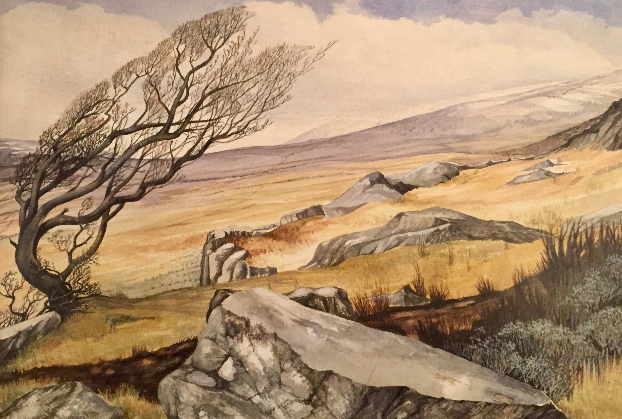

One of Christine’s watercolour paintings – North Wales

Jill is clear that Christine would not wish anyone to be sad now at her leave-taking.

Even when the end of a life comes at an advanced age, as Christine’s did, so that it cannot be said to be a surprise, still nothing prepares you for the shock of the reality of death – for the ‘Christine-shaped’ hole that it leaves in your lives; and for how that absence feels.

One of the things that does have the power to sustain human beings at such a time is to feel the support of others who, in the face of that loss, share your sadness. So together, with dignity, in grief, we’re going to pay tribute to Christine, mourn her and celebrate her life.
So that I could write a ceremony that would do Christine justice, I asked Jill what words, objects and memories she would choose to introduce me to something of the ‘essential Christine’.

- I heard about a woman who was GIVING / INDEPENDENT / CREATIVE
- I encountered an amazing artist
- I made the acquaintance of a kind and devoted wife, mother and friend.

If a portrait of the ‘essential Christine’ was taken or painted, it would likely depict one of the valleys on Cannock Chase, and there would be at least one Boxer dog featuring prominently in the picture. Christine would be in the landscape, maybe at an easel painting the vista around her, or pausing to chat with others.

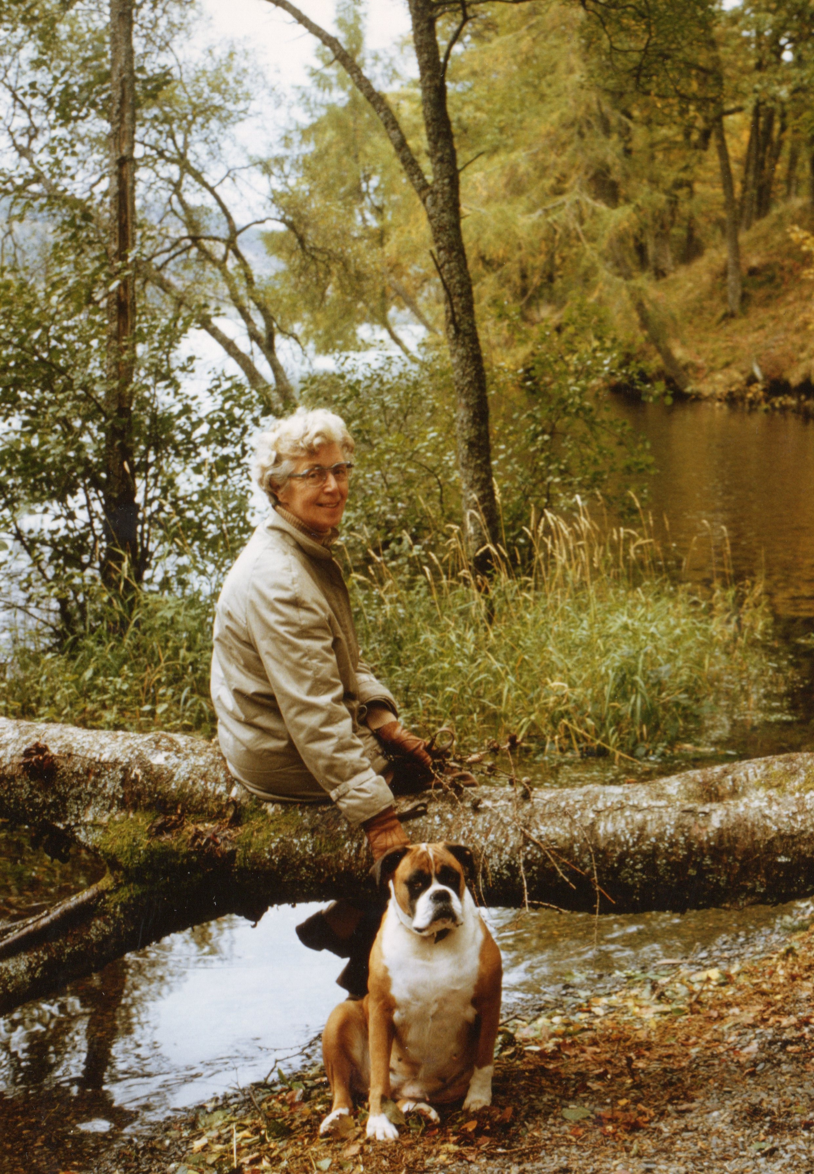

On Cannock Chase with Sally

The first reading we’re going to hear acknowledges and celebrates the cornerstone of Christine’s life; that is, her long and devoted marriage to Ken. Ken died in March 1992, but a few years later, on holiday in Wales, she wrote a poem for Ken that I am going to read for us today.

FOR KEN: WALES, SEPTEMBER 1998

Today, the sky was full of angel’s wings
‘There are no such things’ I hear you say
And yet high on a hill above the sea
With sun-drenched grasses cradling me
I lay and watched the clouds go by
Great billowing shapes
Against an azure sky
Like tall ships, full-sailed
In line ahead they go
Armadas off to fight some heavenly foe
Some battle lost in time and space
They move towards it with such grace
Lost in thought I watch them go
Scarcely noting now how strong the wind did blow
It bent the grasses with such force
My cloud Armada lost its course
Their wind-filled sails were torn to shreds
Whipped by this wind to tattered threads
Thousand upon thousand of feathered things
That looked to me like angel’s wings.

THE JOURNEY OF CHRISTINE’S LIFE
Let’s hear some more about Christine’s ‘life journey’.

Christine’s family has deep roots in Staffordshire. Indeed, the village in which she was born, Little Haywood, is cited in the Doomsday Book of 1086 and it remained a small village right up until the housing expansion during the 1980s, when it expanded into a commuter village, serving north Birmingham.

Christine was born in 1923 to Christopher Hazel and Hettie Sproston, each of whom had had lots of brothers and sisters. This meant that, although Christine herself was an only child, she had many aunts, uncles and cousins all over the country. The little family moved to a house in Milford when she was 3 years old and from then on, she had the joy of growing up on the beautiful Cannock Chase.

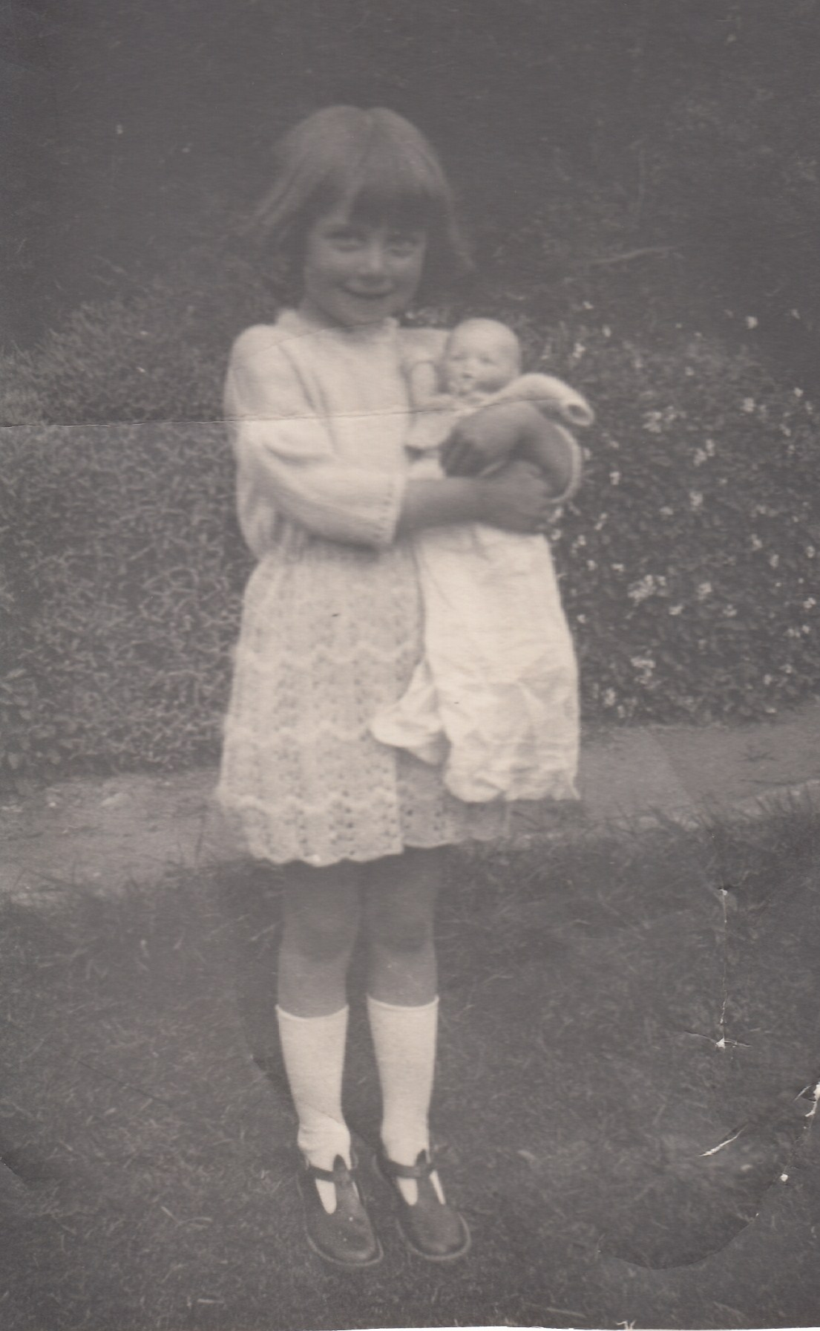

Christine in 1920s

One of her closest friends over her whole life was Dorothy Groucott, who became Dorothy Pugh and who is here today. Chris’s love of the Chase also lasted a lifetime and she spent many hours walking and painting up there. She used to tell the tales of walking over the Chase on Christmas Day in the snow with her parents to family parties in Little Hayward and Great Hayward. She had a happy childhood with an extended family, messing about on the river near Shugborough and enjoying the company of friends and her dog, Flo.

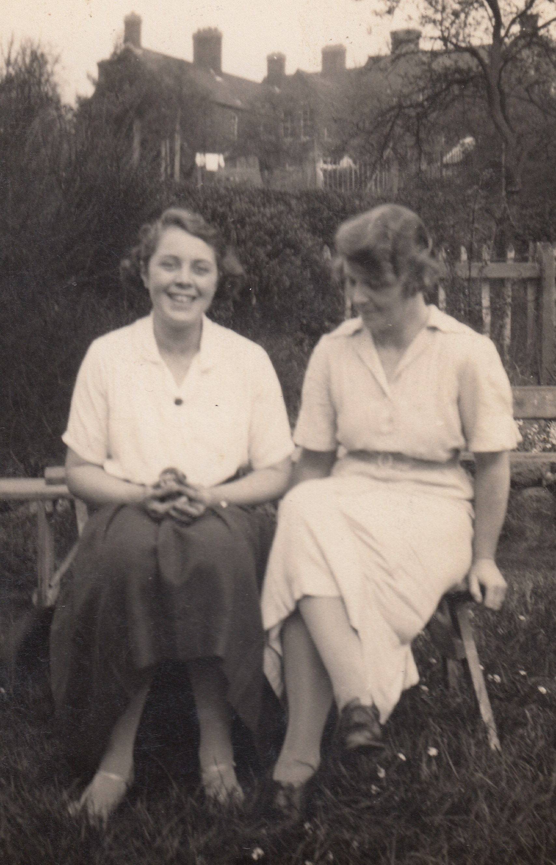

Christine in the garden at Milford with her mother Hettie in 1930s

Despite doing well at school, she had to leave at age 14 to get a job. But she was determined to pursue her love of art and so, several nights a week, after work, she went to art school to train.

It was during her teenage years that she would stay with her beloved Auntie Lily and Uncle Arthur down in Ewell. She adored them and their two young boys Colin and Michael, who although technically her cousins, were more like the brothers that she didn’t have. Michael’s daughter Louise, who is here today, tells us that her father, who was quite scared of females, clearly looked up to Chris, and she seemed a real source for the good when she came to stay with them in Ewell.

When she was 16 years old, WW2 began and life changed. By then, she was working as a draughtsman at British Reinforced Concrete, which she loved.

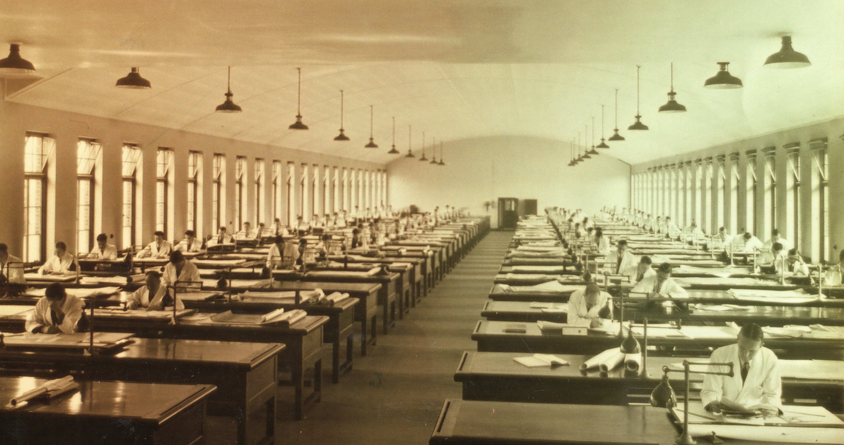

The drawing office at Stafford BRC in 1940s

In the evenings, she served in the Home Guard. During the war, three of her cousins were evacuated from Liverpool to live with Christine and her Mum and Dad in the relative peace and safety of Staffordshire.
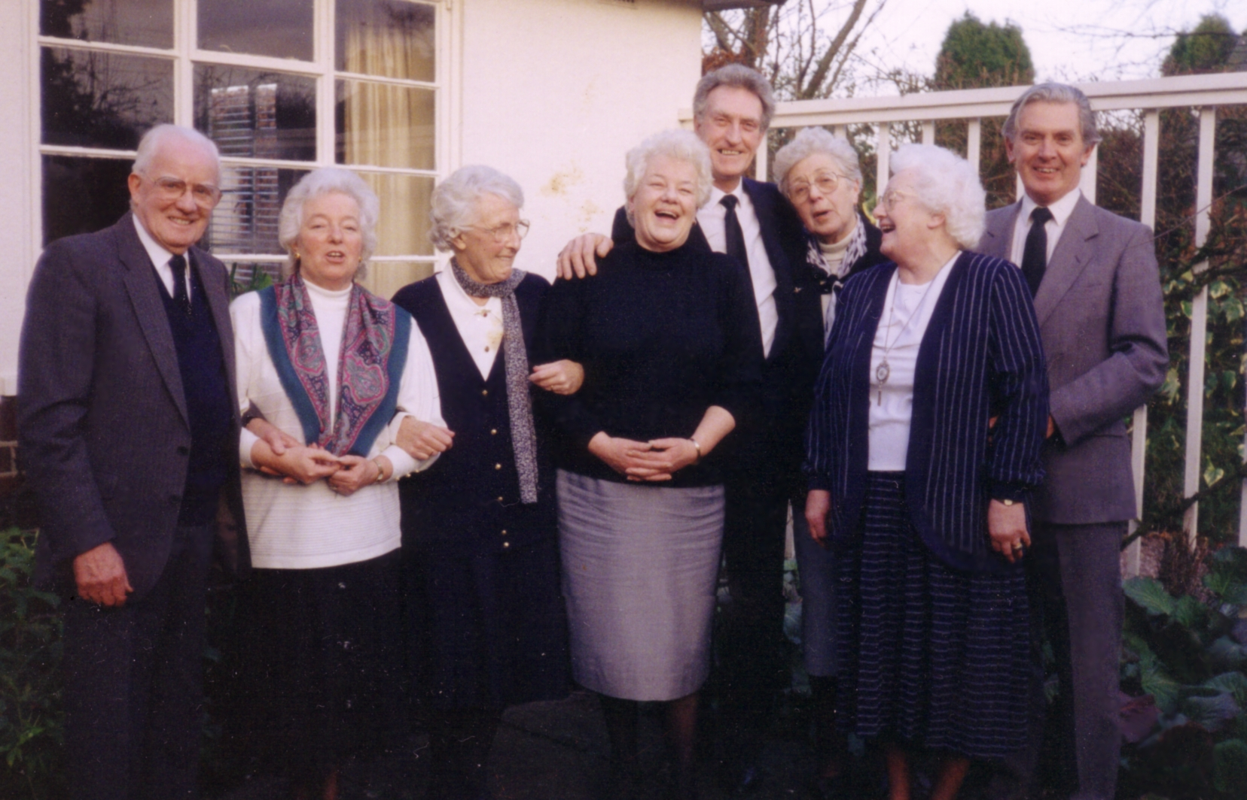

A lovely photo above of Christine (3rd from R) and some of her many cousins including Michael (far R), the three Liverpool girls (Barbara, Sheila and Joan), and Dorothy Godwin (3rd from L)

It was during the war that she became engaged to her childhood friend Vic Parker - but he went away to sea with the Royal Navy and came back, as happened to many young women, having changed his mind about their engagement!

Time would prove that this was for the best, because, whilst working at the County Architects Office, Christine then met her darling Ken Finlow. He had been medically discharged from the RAF having contracted polio and having spent 18 months lying flat on his back. When they met, he was still on crutches and, because he had been given a very gloomy medical prognosis, they were not sure how long he would live.

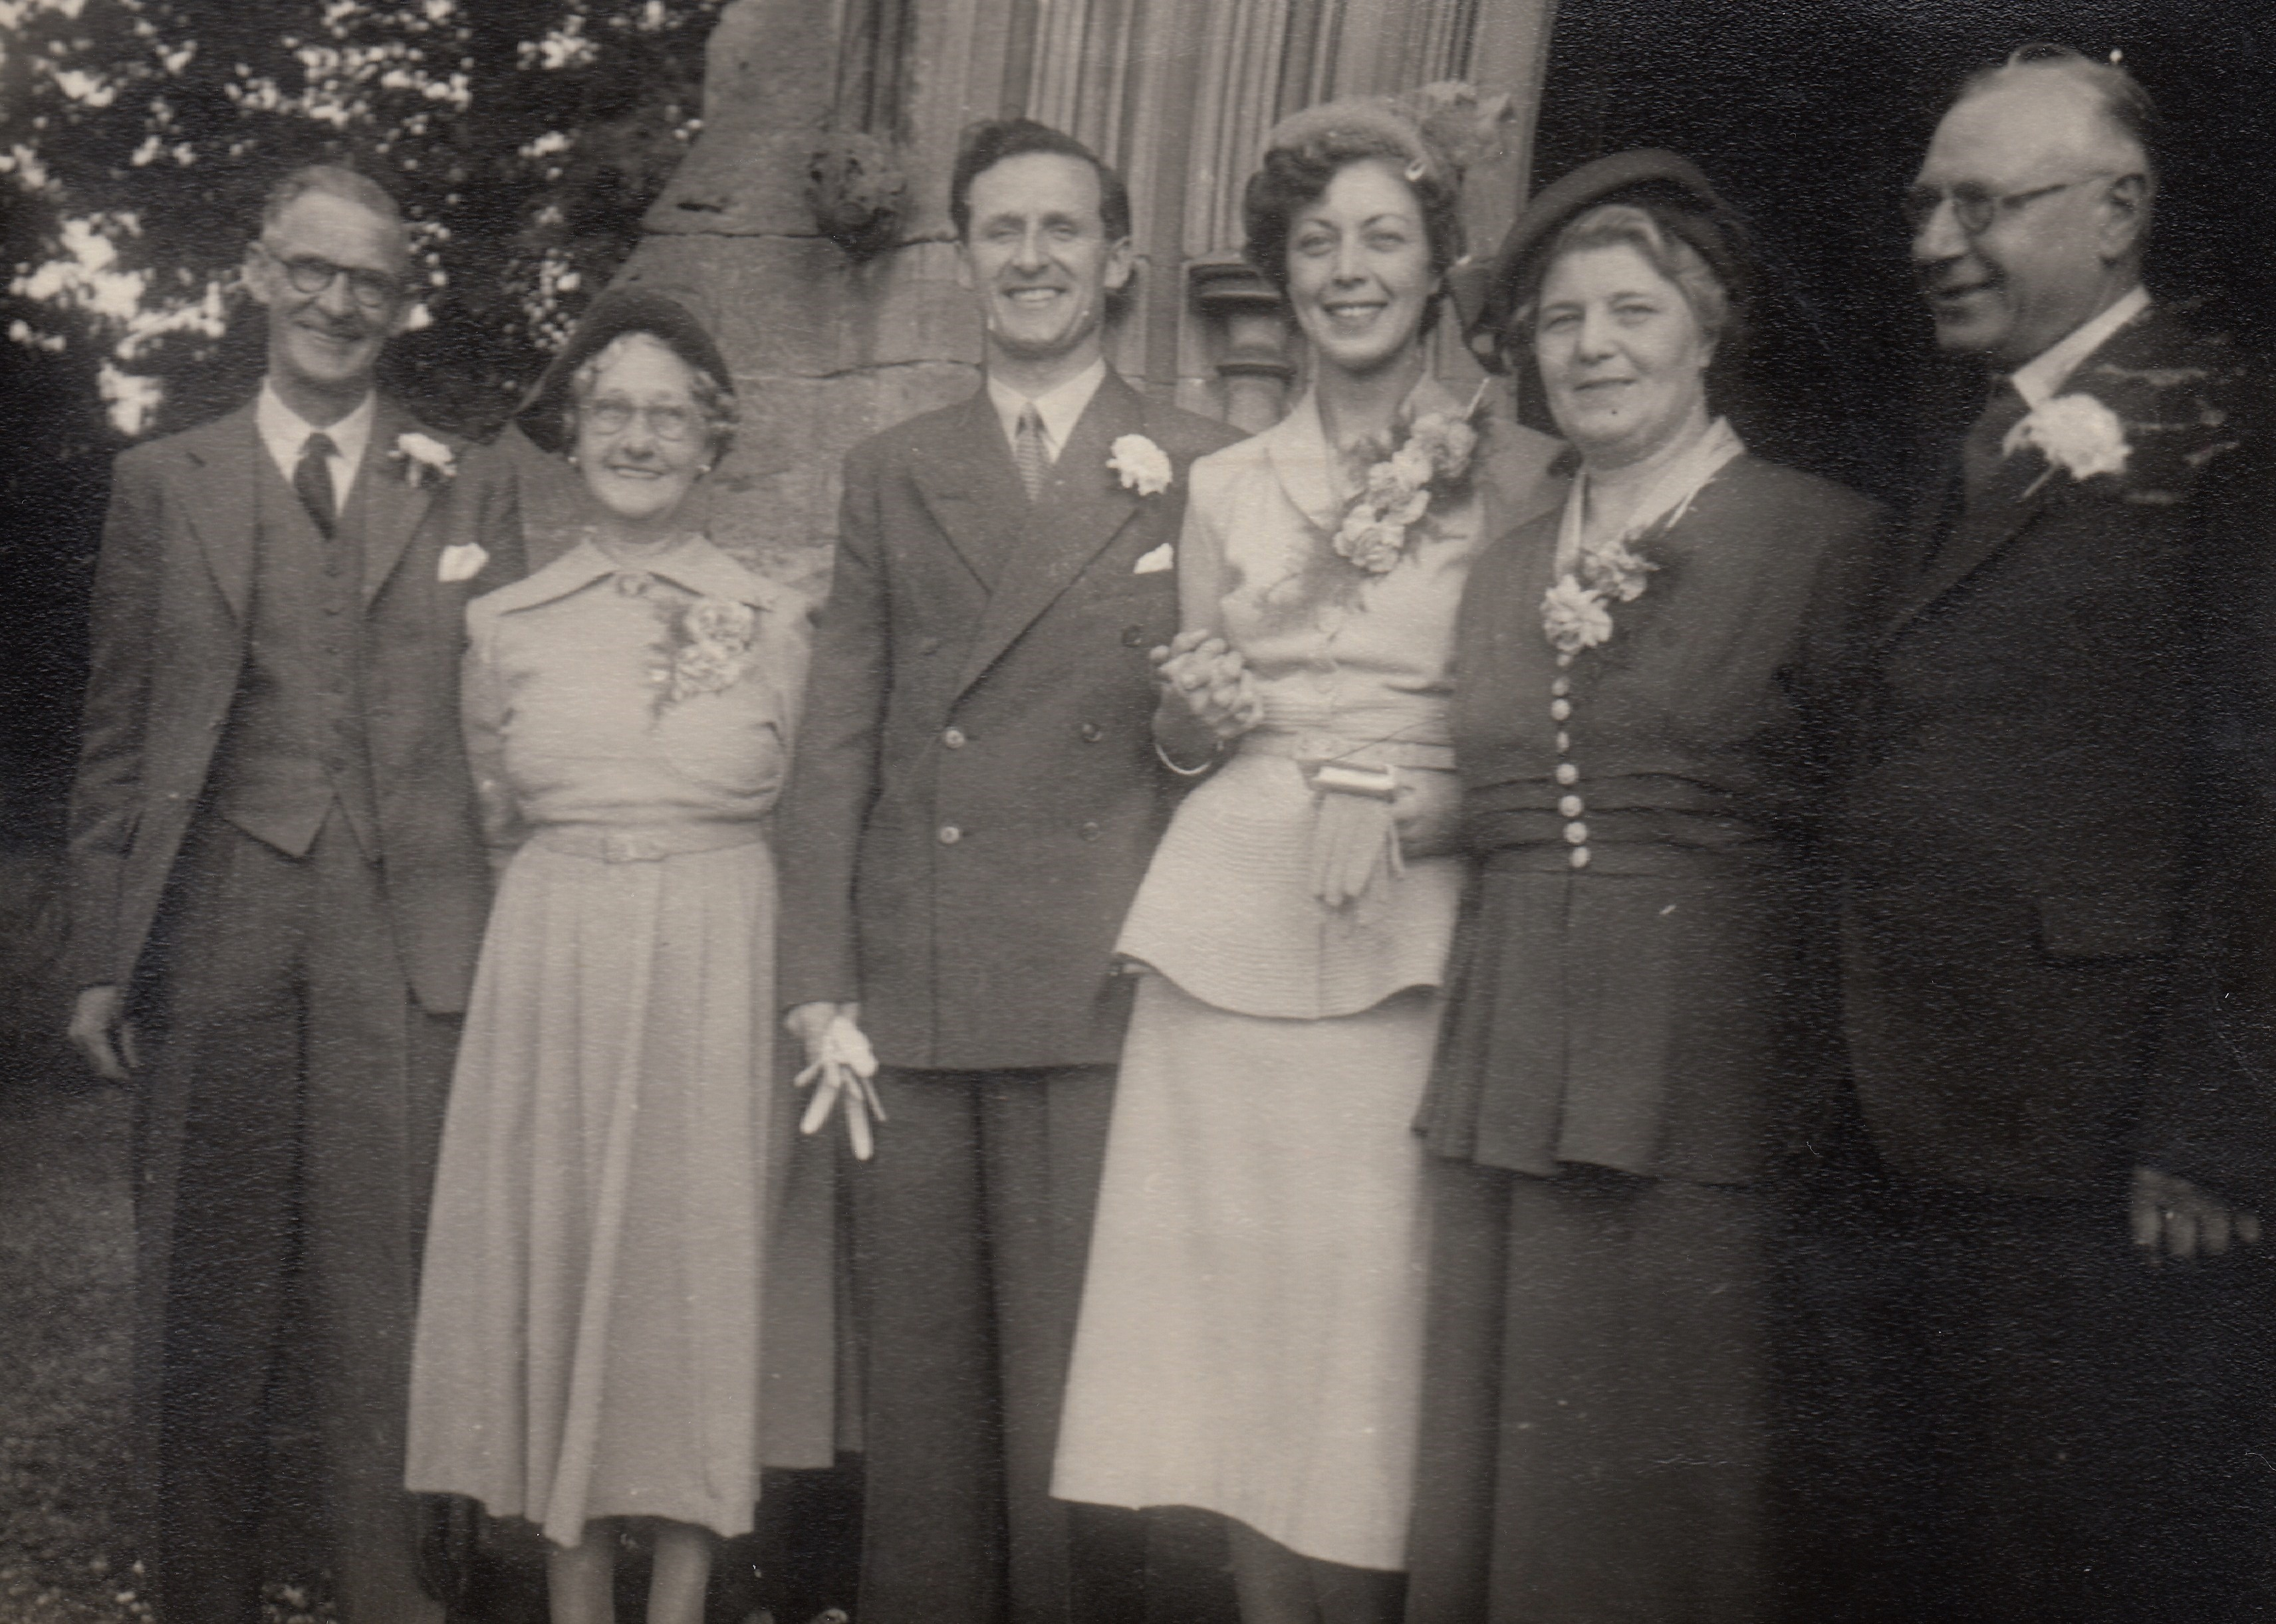

Getting married in 1950s with the parents

Together they designed a beautiful house and garden, where they lived happily with the boxer dogs - Bill, Cindy, Sally and Sophie - until he died in 1992. Christine adored Ken - he was a good man, with a fun sense of humour and he gave her the confidence that her father had been less able to provide.
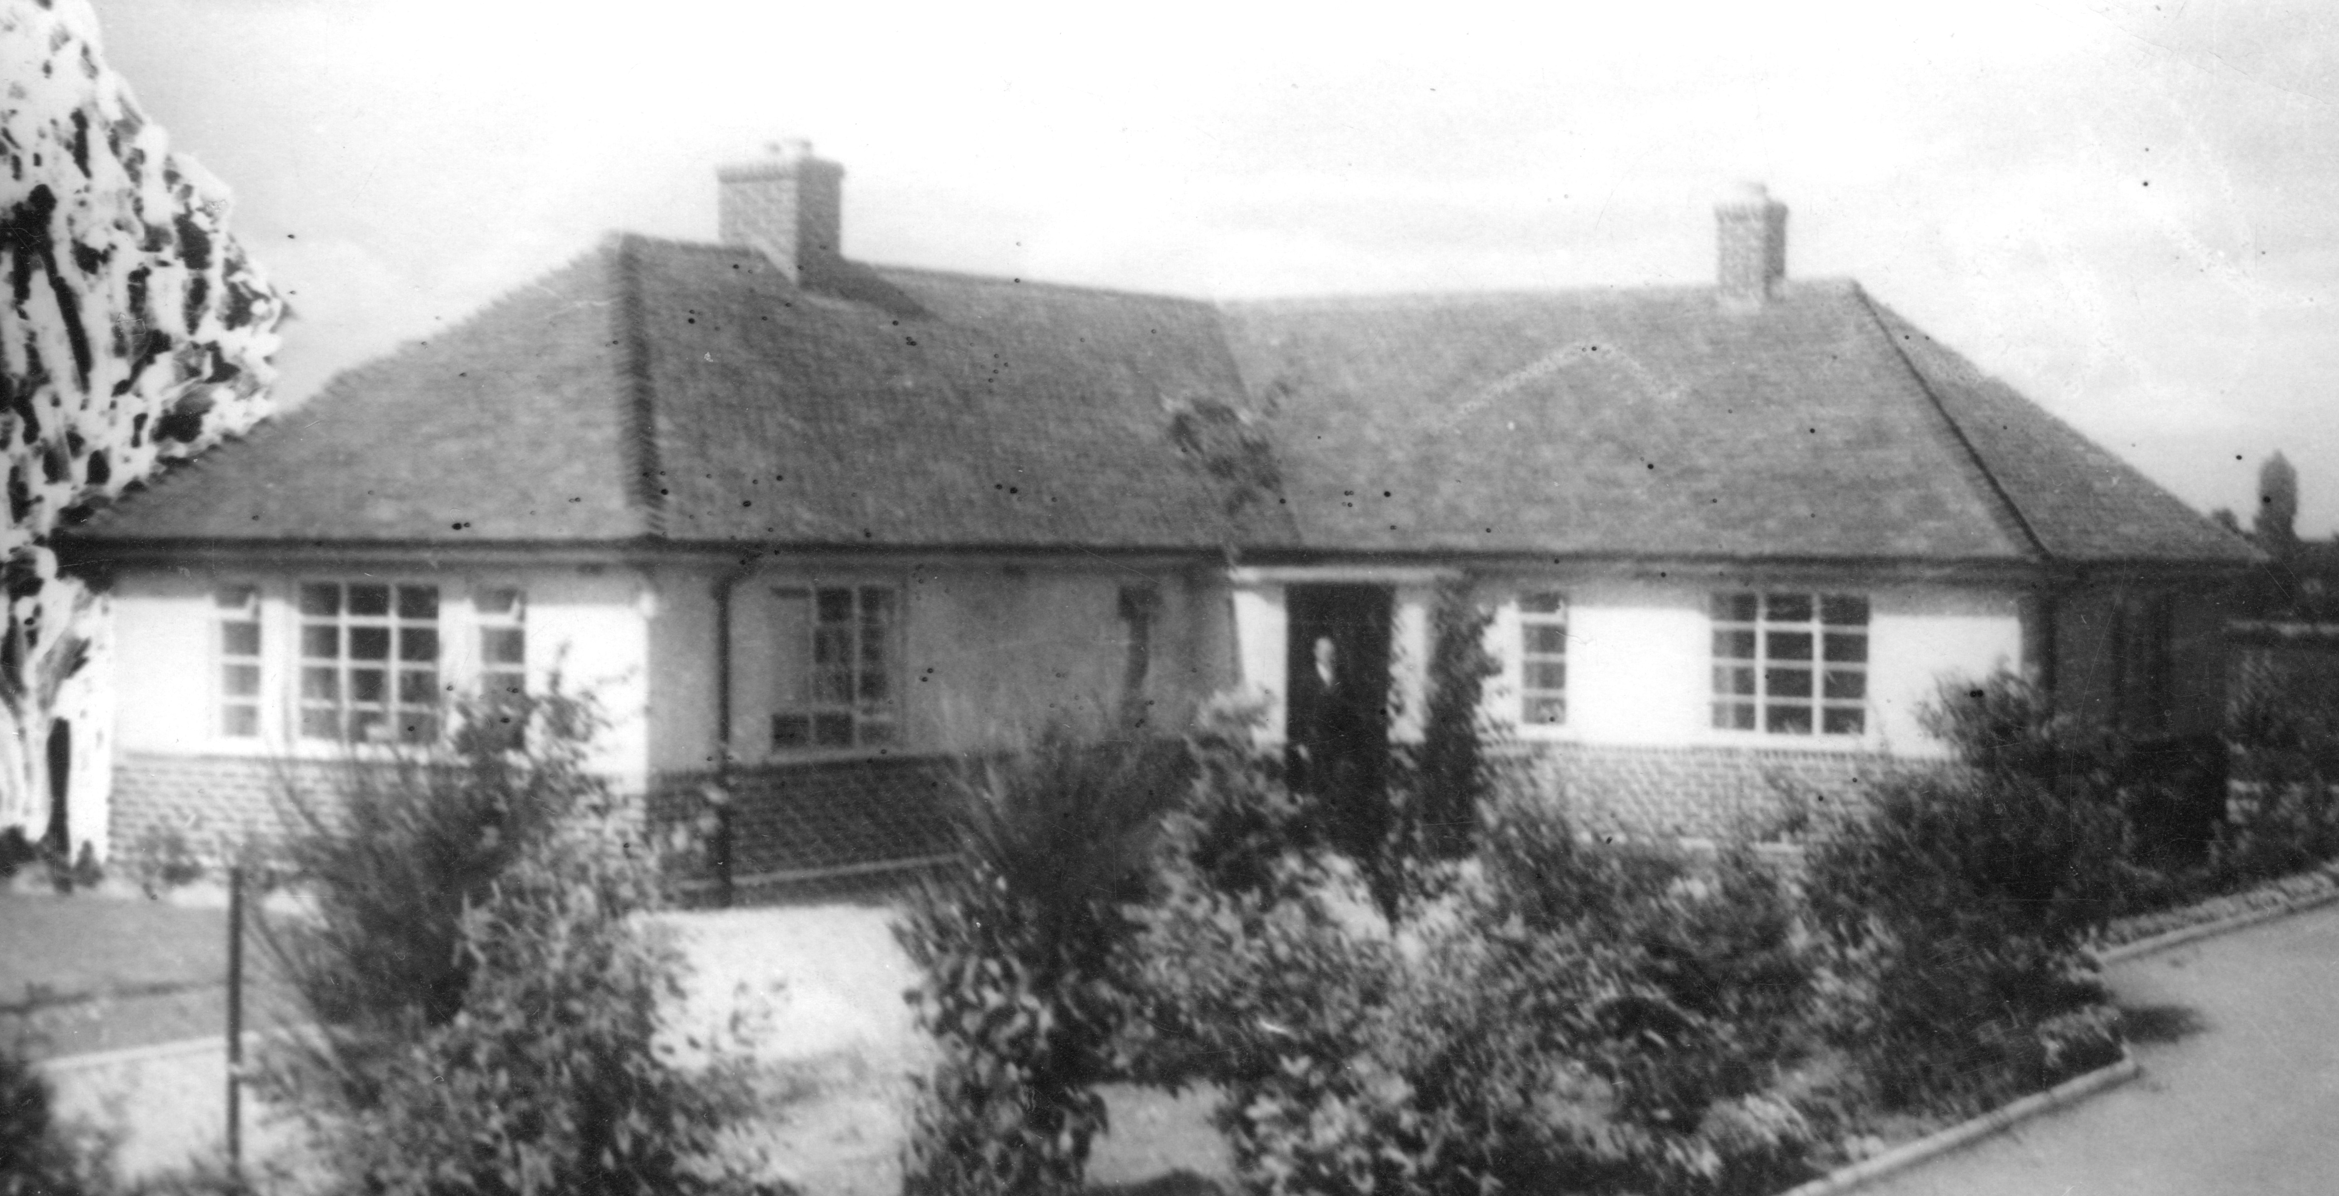

Their home in 1950s

Jill, their only child, was born in 1957 and they gave to her all the unconditional love and support that a parent can give a child. Jill remembers her mum walking with her and boxer, Bill, twice a day to Berkswich school – the same school that, 35 years earlier, had been attended by Christine and Dorothy. Chris may also have provided Jill with a helping hand with her art homework!

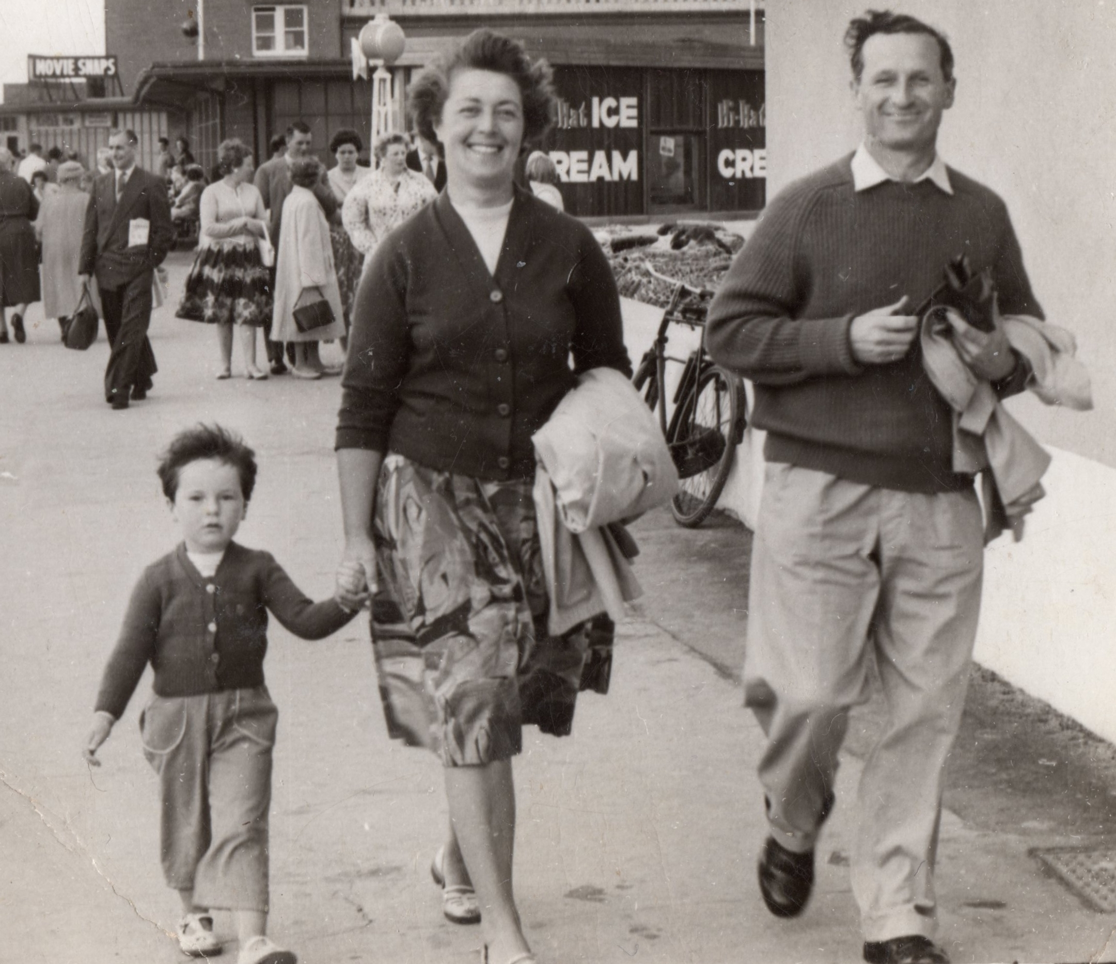

On holiday with Jill in 1960s
Once Jill was at secondary school, Christine went back to work at Staffordshire County Council, this time in the Planning Department, where she thoroughly enjoyed working as an artist - drawing canal bridges and locks, imagining historical reconstructions, and illustrating many maps and other official publications. Throughout this period she carried on with her own watercolour painting, whether commissioned canvases or just for fun.

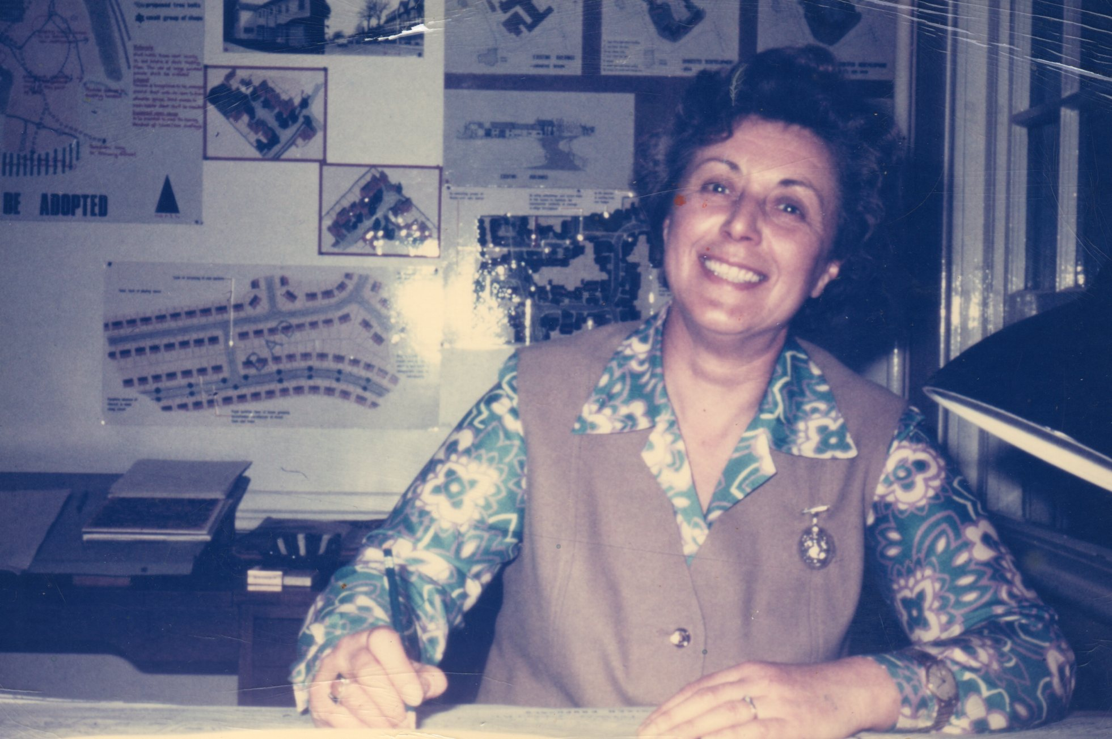

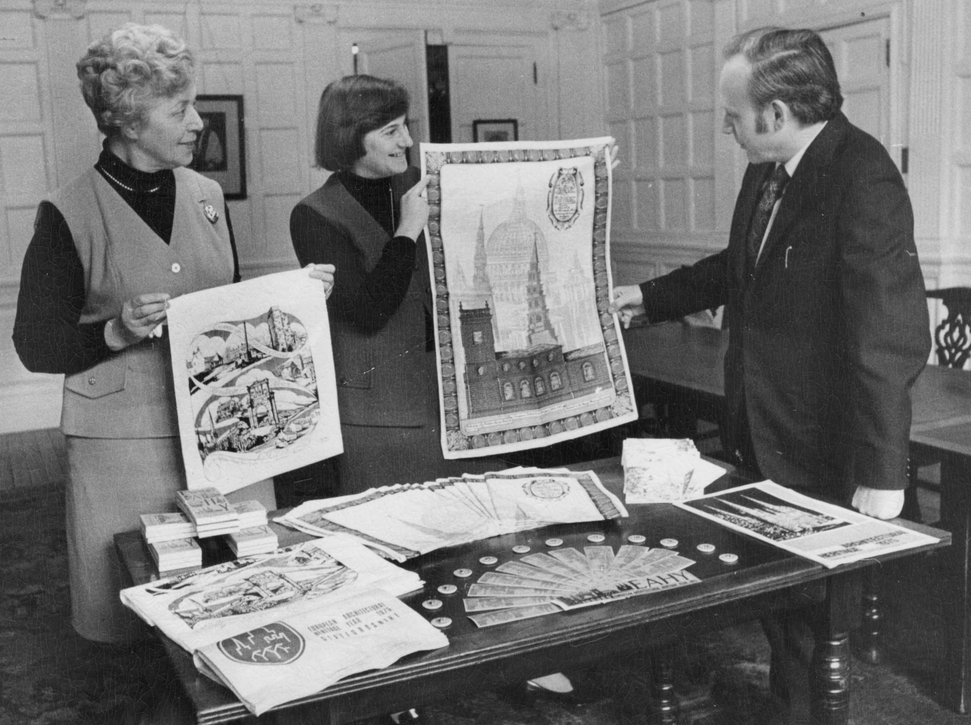
Christine’s artwork for the Planning Office in 1970s (pictured here with her good friend Mary)

Family holidays in Criccieth with the Asquith and the Darvill families provided inspiration for many lovely paintings of the Lleyn Peninsula and other parts of North Wales. After Ken died, Chris continued to travel to Criccieth with her dear friend Norah.

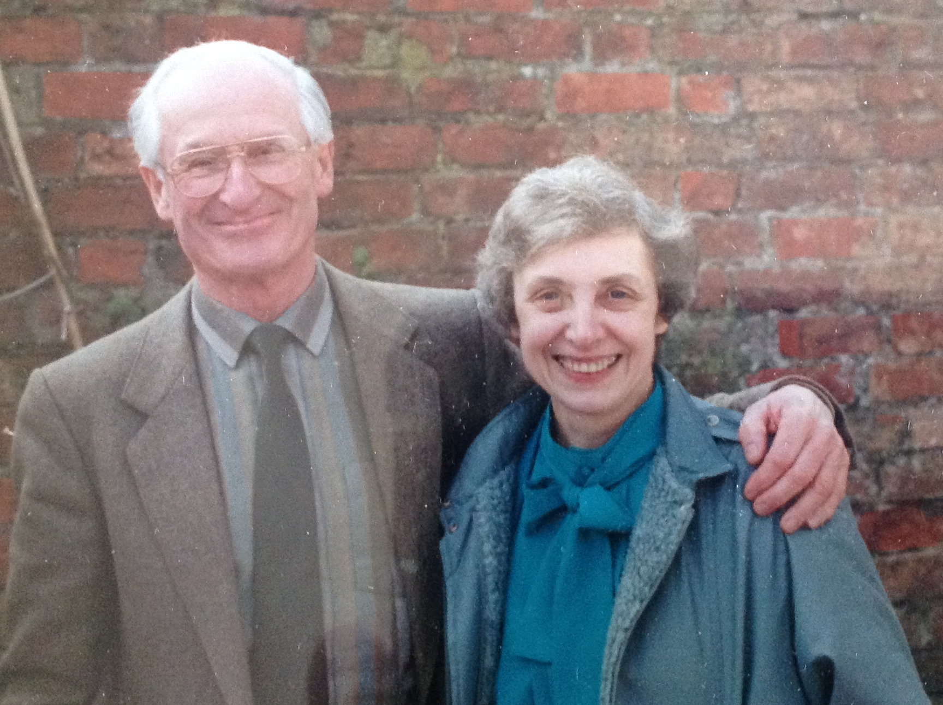
Ken with Norah

Another art foray was painting pub signs - which she did with Les Pugh, Dorothy’s husband, who was himself a talented painter. Jill recalls the garage being full of six-foot high oil paintings of the Saracen’s Head and detailed heraldic coats of arms that had all been meticulously researched…although allegedly, the face of the Saracen resembled the landlord of the time!

After Ken died, Chris kept busy for many years looking after people, her dog and her lovely garden. Slowly, as old age and medical problems took their toll, she needed more help and both she and Jill were and are eternally grateful to her local friends Terry and Sylvia, Pam and Robert, as well as, of course, her lifelong friend, Dorothy. Thanks also go to the many carers who attempted (usually after a battle of words) to support her in her own home. In particular, one carer, called Carol, went above and beyond in the support that she gave both Christine and Jill.

5 years ago, Christine moved into The Manor House Nursing Home, where she continued to be her feisty, funny and, on occasion, her slightly obstreperous self - a trait that seemed to endear her to staff.

When the end came it was relatively quick and painless for which Jill was very thankful. Jill believes that her mum had had enough and wanted to sleep. In her waking moments, during their last few hours together, mother and daughter spoke openly and frankly, sharing their love for each other and their mutual thanks for the experience of such a good life.
We’re now going to hear some tributes to Christine, which will give us a better sense of the wonderfully rich palate of experiences that her family and friends enjoyed with her.

The first was written by Kathleen (Norah’s daughter) and she’s called it ‘Memories of Chris’:

Memories of Chris

Walking on Cannock Chase – always an adventure. ‘But it says ‘Strictly No Entry. Private, Chris.’ ‘Oh, I’ve always walked through here, I’m not going to stop now!’ as she straddled the gate and jumped down into the woodland the other side. She took a similar line with the Shugborough Estate when it was closed to the general public and liked to recount the time she was walking in the direction of the house with the dog and returned an enthusiastic wave to someone driving through some distance away in a sports car.

Turned out it was Patrick Lichfield!

She came a cropper, we believed, when her non-conformist line landed her a B at A level Art compared to my father’s A. We all knew who the artist was and we assumed she must have gone ‘off piste’ with the brief. Never mind, she soon got over the outrage, and they’d had an enjoyable time going to the classes, sneaking the odd cigarette together before driving home again.

I was invited to spend a few days in Criccieth with Chris during the Summer before going to Uni. Sketching (her, not me), walking, enjoying the coast and scenery, picking field mushrooms, cooking, chatting. What a source of fascinating information on history, art, nature, life in general. Ironically, a fantastic, vivid memory and sensitivity for detail.

The jokes always came thick and fast too and it was frustrating never being able to remember any of them afterwards, or reciprocate, (not being the kind of person who ever remembers punch lines!). The jokes she maintained she’d been told by the vicar always seemed to be the naughtiest.

Chris and Ken’s home and garden were lovely places to be and both had had the benefit of an artist’s eye. Often cakes would be baking in the kitchen, always to be given away. No ingredient measured, always massive and utterly delicious. The garden was beautiful and encouraged as something of a haven for wildlife. We’d visit the Art shed with her at the bottom of the garden and look through the portfolio.

I remember scenes from Cannock Chase and her beloved Pennant Valley. We were challenged to find her initials hidden on her sketches produced for the Council and, later on, we would come to admire the pub signs she so enjoyed painting. She also took delight in doing a spot of painting with my budding artist daughter, and that daughter has fond memories of their time together to this day.

We would chat to Ken in the greenhouse as he tended to the vast array of begonias and would invariably return indoors to find a generous tea laid out. We learnt to turn up hungry and not cause disappointment.

Chris baked and decorated a beautiful cake for my mother’s 60th birthday lunch. They remained close companions and supported each other as widows. The last photo I have of my mother is one taken by Chris when they were out having tea and cake. My mother, riddled with cancer, is beaming from ear to ear and looks very happy. She always was, when she was with Chris. That’s because Chris radiated love.

A place was always set on the kitchen table for her dear departed Ken, and it was a loving not a sad gesture. Chris used to say she always felt him near. I sincerely hope they are together again now. On this earthly plane they live on in many, many, many people’s hearts.

Thank you, Kathleen.

The next tribute was penned by Christine’s cousin Colin and sent to Jill by him and his wife, Eileen. It’s called ‘My Cousin Chris’:

MY COUSIN CHRIS

My Cousin Chris
We all will miss
What stories
What laughs
What talent
What painting
What a daughter
What a wife
What a mother
What a friend
We all will miss
My cousin Chris

Love Colin & Eileen

Thank you both!

At this point, there was an open Invitation to those assembled to make any prepared or spontaneous contribution to the tributes. Norah’s youngest son, Christopher, spoke warmly and fondly about his ‘fairy godmother’.

The final tribute has been written by Andrew (Michael’s son) who is Ken’s godson…but who, early on, made Christine his ‘chosen god-mother’...

‘I will always remember her as a truly remarkable lady, and I always enjoyed her company enormously. She was so full of fun and humour, and there was a good to-and-fro of conversation.

At the same time as that soft side, I had the impression that she was a strong and formidable character too. I guess that she had to be after the death of your much-mourned father. It must have been hard for her to bear that.

The phrase ‘indomitable force’ is springing to mind, and I am not at all surprised to hear that she was, to a certain extent, in control of her own destiny to the last – when, [you say that] as Jill explained, she had decided enough was enough.

Chris stands out as the life force: someone on whose every word I would hang, whose every laugh filled the room, even on the end of the phone.’

Thank you very much, Andrew.

To round off this account of a ‘good life, well lived’, I am going to read the powerfully life-affirming lines of the poem by Leo Marks that was used to encode messages between fighters in the WW2 Resistance, like Violet Szabo. It was a poem that Christine kept on her bedside table next to a photo of Ken and Jill.

THE LIFE THAT I HAVE

The life that I have
Is all that I have
And the life that I have is yours.

The love that I have
Of the life that I have
Is yours and yours and yours.

A sleep I shall have
A rest I shall have
Yet death will be but a pause.

For the peace of my years
In the long green grass
Will be yours and yours and yours.

Leo Marks (1920-2001)

QUIET REFLECTION
You all have your own individual memories of Christine and this is the part of the ceremony when you have the chance to sit quietly and remember her in your own way. Whatever your own memories of Christine…this is YOUR time for personal and private reflection.

We’re going to hear part of Beethoven’s ‘Pastoral’ Symphony, played by The Berlin Symphony Orchestra, conducted by Sir Simon Rattle.

MUSIC:
‘PASTORAL’ SYMPHONY: Ludwig van Beethoven
Played by The Berlin Symphony Orchestra Orchestra, conducted by Sir Simon Rattle.

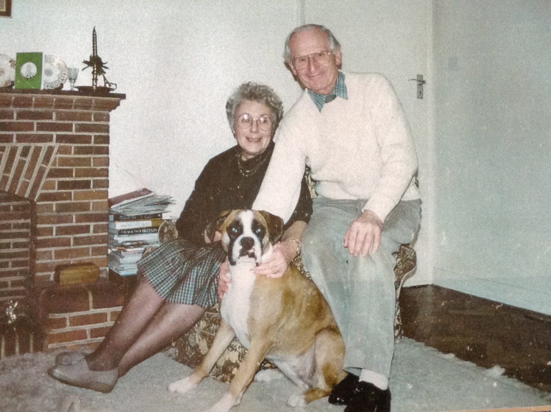

At home with Ken and Sally in 1980s

THE COMMITAL

In celebrating Christine’s life, we have paid tribute to this mother and friend whom you all love and miss.

We are also here, however, to say a formal farewell to her – and the time has now come for us to do this.

Even though the life of Christine Finlow has ended, the spiral of her family’s life lives on, especially embodied in Jill, and those of the younger generations, on whom, as we’ve heard, she made such an impression.

You are more rounded human beings for having known her.
You treasure - each in your own way - the ‘indomitable life force’ that she embodied.

You have been warmed by her care and love and inspired by her encouragement, advocacy and support.

You remember with gratitude her love of life and the way she welcomed and supported family, friends and neighbours with her time and her wisdom and you will continue to hold her in your hearts.

Such as life-loving person as Chris cannot be diminished, not even by death.

- Seizing each day, as she did, with energy and love, and having lived her life to the full, you will hold in your hearts the caring, independent and creative person you knew and loved.

- Guided by the example she set you, she will live on in your lives.

- With respect, courage and love, we commit Christine’s body to its natural final resting place and let her go.

CLOSING WORDS
Even though, at the moment, the absence of Christine is keenly felt, your lives are richer for having had her in them.
She will still be woven into your lives and your community, threaded through your shared memories of her.
Through Jill and her many cousins and ‘chosen family’ members, the genetic and ‘influence’ legacy of Christine and her kin spirals on into the future.
She also lives on through the way that she touched the lives of her wider family, friends and colleagues, over so many years of shared living and working.
Hold onto Christine in your endeavours, your hopes, your thoughts and your hearts.
Don’t be afraid to talk about her, cry about her, laugh about her and, of course, continue to live her legacy in your own fruitful future lives.

To close, we’re going to have a taste of the kind of wit that Christine appreciated. Long before Joyce Grenfell’s better known ‘take’ on it, this poem was written by the great Shakespearean actress, Ellen Terry (a Midlander herself) and it challenged the Victorian & Edwardian era’s maudlin and overly gloomy relationship to the certainty and normality of death…

It’s called ‘No Funeral Gloom’…

NO FUNERAL GLOOM

No funeral gloom, my dears, when I am gone,
Corpse-gazing, tears, black raiment, graveyard grimness.
Think of me as withdrawn into the dimness,
Yours still, you mine,
Remember all the best of our past moments and forget the rest,
And so, to where I wait, come gently on.

Ellen Terry

Jill wants to express her thanks and sincere gratitude to you all for joining her here today, to mourn and to celebrate Christine.

She would also like to acknowledge and thank all the staff at Manor House Nursing Home, where Christine ended her days.

As we leave this space, we’re going to be played out with an uplifting ‘swing’ classic, that can’t but get your toes tapping as it carries you over the threshold, out into the beautiful and life-reawakening spring day that awaits us there…

It’s Glen Miller & his Orchestra, playing ‘In the Mood’.

MUSIC ON LEAVING
IN THE MOOD: Glenn Miller

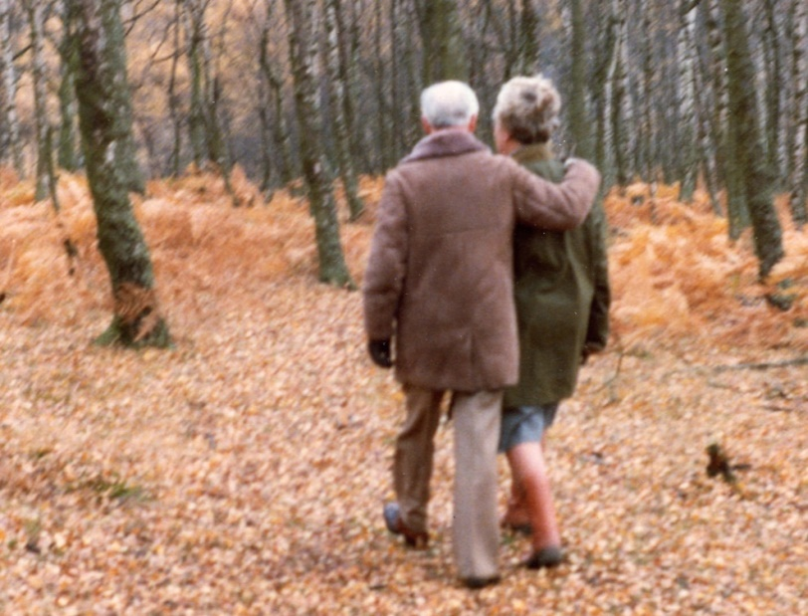

Together again at last

