A CELEBRATION OF THE LIFE OF

DAVID FRANCIS KIRKWOOD
6th June 1927 – 17th August 2018

held at
Perth Crematorium
on 31st August 2018

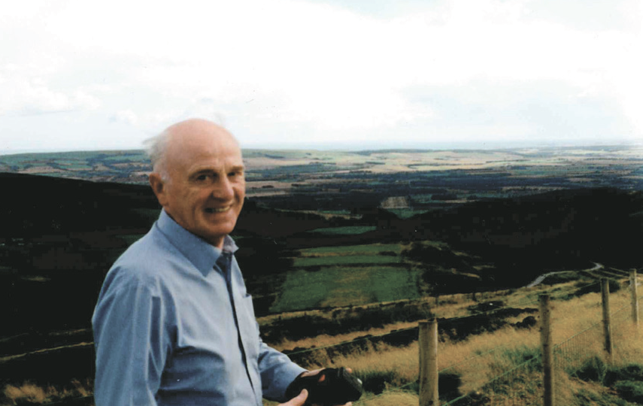

Humanist Celebrant
Ian Willox
01865 589 663
ian.willox@humanistceremonies.org.uk

Humanists UK
39 Moreland Street, London, EC1V 8BB
020 7324 3060
www.humanism.org.uk

Funeral Director
James McEwan & Son
Perth

ENTRANCE
STRANGER ON THE SHORE – ACKER BILK

OPENING WORDS
Good afternoon everyone. We’re here to celebrate the life of David Francis Kirkwood who died on 17th August aged 91.

INTRODUCTION
For those of you who don’t know me - my name is Ian Willox. I’m a celebrant for Humanists UK. A wee while ago David asked if I would be the celebrant for his funeral. I had hoped it would not be this soon.

Humanist funerals are non-religious. That doesn’t mean anti-religious. This is a ceremony for everyone – including those with a religious faith.

THOUGHTS ON LIFE AND DEATH
With or without religion one of the purposes of a funeral is to remember – so that David lives on in our memories at least.

So lets remember…

TRIBUTE
The trouble is where to start and where to finish. Because David was a fount of anecdotes and stories about his life – far more than we have time for this afternoon. But let’s see how we get on.

David’s father, Neil, was a cattleman and his mother a housewife. He had an older brother, Jack and a younger one, Neil.

David was born in Perth – but the family moved around a lot. He attended 11 different Primary Schools. Not good for your education. Not good for friendships. His first school was Barry Primary near Carnoustie. His grandson Robin went to the same school.

If you were out for a drive with David he’d keep pointing out places he had lived.

Shona told me a story of David as a child, on the banks of the Tay, watching an aircraft taking off from Dundee. He ran home to tell his mother he’d seen a “double decker” plane. She gave him short shrift. But he had. As a quick Google revealed.

On 6 October 1938 the Maia flying boat took off from the River Tay with a Mercury seaplane on its shoulders.

After getting about six miles outside Dundee, between the city and Forfar, the planes separated and the Mercury headed towards Africa.

It touched down on the Orange River, descending through a cloud of Flamingos, and setting a seaplane distance record of 6,045 miles.

A typical David story.

World War Two started. David told his grandson Paul of how, in their remote Auchterarder farmhouse hearing a squadron of German bombers flying over one night. And then seeing Glasgow lit up by the bombing raid on Clydeside.

When David was thirteen and a half he was put out of the house and into private service.

I remember on a shoogle with him we visited the site of Dunira Hospital near Comrie where he had worked as a stretcher bearer. He remembered the nurses taking him into Comrie and getting him drunk – aged fourteen.

Then he went to Alloa House to work for Lord Marr as a footman.

But in 1946 National Service loomed. David’s training was not without incident. A gentle soul like David probably wasn’t ideal military material.

He was a batman. It reinforced his tidy and orderly ways.

He trained to be a parachutist. His first jump was from a static balloon. He wasn’t that keen on leaping out into thin air. So his instructor pushed him. As David floated to earth he realised he loved parachuting. Almost as much as he loved dancing.

The thing about being a parachutist is that you had access to parachute silk. A very popular thing in rationed Britain.

David was caught trying to leave camp without a pass to visit his mother with a gift of some parachute silk. He and all the other defaulters of that day were lined up to be shouted at by an officer.

The officer worked his way down the line. He got as far the miscreant next to David. “What’s your excuse?” the officer demanded. “I’ve got a sister in the WRENs sir. And she’s excused boots.”

You’ve all probably heard the story. David loved to tell it. It always cracked him up.

And I’ve still no idea what it meant. Which was probably the point.

David could surprise. Apropos of nothing he would mention the time he was imprisoned in Scotland Yard. It’s hard to think of David as a master criminal.

He was caught on the London train using a travel pass that wasn’t his. And detained overnight.

David’s grandson Paul went for a long drive with him one day and recorded his reminiscences. Some of the memories were unexpected.

David told Paul about the habit of women in the face of the wartime nylon shortage painting on stocking seams with eyeliner. Paul was surprised and asked David what he thought about this. “Easier and quicker” was his response.

David was sent out to Palestine which had become the destination for thousands of post Holocaust Jews. A messy time. A morally challenging time.

David’s last job was to escort a prisoner back to England. He was handcuffed to a soldier who was to be tried for crimes committed back in his homeland.

On demob David returned to his job as footman at Alloa House. The sudden death of the butler got David promoted to the job. David said he thought he was set for life.

He told Paul that he would work all day and then as soon as he was allowed to finish for the day, (usually quite late) he would rush back to his room, get washed and dressed and sprint to the local dancing where he would dance all night. He would come home just before his shift started to begin his daily work again. He did this a number of times a week - quite a lad. He LOVED dancing.

Then David’s father died. David went home to look after his widowed mother. They had a house in Huntingtower and David got a job as Night Manager at Lumsden & Mackenzie, bleachers in Huntingtowerfield – a job he kept for years.

He met Christina – remembered fondly as Tina (pron “Tyna”) - at a dance in Alloa. David could dance. So she married him. David and Tina set up house together. June was born in 1952 – though tubercular meningitis meant she was hospitalised for eighteen months of her early life.

The family moved to Roman Road – where Shona was born – then bought Parkhill in Cromwell Park. David worked like a Trojan on doing up the house and the garden. The house he was most fond of.

Once June and Shona had left home and married, David took a job in Edinburgh as Commissionaire for the accountancy firm of Cheine & Tait. They had a tied flat underneath the offices.

David – always dapper – loved the job and the smart uniform. He would do his rounds in uniform accompanied by his dog Lady. Tourists would take photos of him.

But, reluctantly, David eventually had to retire and he and Tina moved back to Perth, to Cleeve Drive.

While on holiday in Spain, Tina died suddenly of a cerebral haemorrhage. She died in David’s arms. A traumatic event made worse by being in a foreign country where he didn’t speak the language. An awful time.

An awful time that, with the help of his family, David recovered from.

He recovered sufficiently to go dancing. Where he met Mary. The new her ladyship in his life. They danced. They went for shoogles in the countryside. Then sadly Mary developed dementia. David visited her often in the care home, offering comfort and support, until her death.

In 1996 David joined Perth Probus Club – and kept up his membership until this year when his mobility became more difficult. He was also a keen member of their bowling team. And a good one. I remember him coming back from a match modestly triumphant having trounced a serious team of Fifers.

David would spend Christmas and birthdays with his family and even a stroke didn’t stop him from driving to Aberdeenshire to see Shona.

At 88 at his Granddaughter’s house for Christmas day he even had a go on a Hover board, all the rage that Christmas, much to everybody’s amazement. Once a paratrooper always a paratrooper.

One Christmas, without warning, David brought a guest. A Christina. Our Mum.

And so began David’s next life. No dancing sadly. But shoogles in the country certainly. Trips to concerts and the theatre. And company for each other.

We all remember how Mum’s face would light up with delight whenever David arrived. He’d give her a kiss. He’d tease her in a way we would never dare. Always dapper. Always entertaining. Always charming. Always elegant.

And if you asked him how he was he’d cheerfully say, “Ah’m hinging by a threid!”

And then the threid broke.

He died peacefully, at the PRI, two weeks ago.

QUIET REFLECTION
We’re coming to the end of this celebration of David’s life. But before we do we’re going to pause for a moment of reflection. A chance for you to digest all you’ve heard. A chance for you to recall your own memories of him. A chance, if you wish, to pray silently.

AMAZING GRACE – GLORIA FRANCHI

COMMITTAL
Just as we welcome a child into our lives we must say goodbye to those who leave us. This celebration of David’s life is complete. It’s time to say farewell to him. This may be difficult but it is important. I hope the memories we’ve talked about here may give you some comfort. Please stand for the committal.

FINAL FAREWELL
Our atoms and molecules come from the earth;
Are ordered by ancestry;
Are fired into life by union;
Are sustained by the earth and powered by the sun;
And return to the earth when life ends.
John Stuffin

David Francis Kirkwood. Son of Helen and Neil. Brother to Jack and Neil. Husband to Tina. Father of June and Shona. Grandfather to Lee, Paul, Dale and Robin. Great granddad Davie to Sam, Jenna, Sean and Faith.

We commit your body to be cremated. Rest in the hearts and minds of all you love and all who love you.

CLOSING WORDS
Please be seated. We’ve celebrated David’s life. We’ve said our goodbyes. But we have our memories. And the rest of our lives to remember.

If you want to share those memories – or just some refreshment – you’re warmly invited to join the family at Huntingtower Hotel. You’ll find details in your order of service.

As you leave you’ll see that you can make a donation in David’s memory to Alzheimer Scotland Action on Dementia. Again you’ll find details in your order of service.

Please take good care of yourselves and each other.

Thank you for coming.

EXIT
MOONLIGHT SERENADE – GLENN MILLER

