A CELEBRATION OF THE LIFE OF

Dr BARRY RANDOLPH MARTIN
17th September 1936 – 25th August 2018

held at
St John’s Chapel, Oxford Crematorium
on 10th September 2018

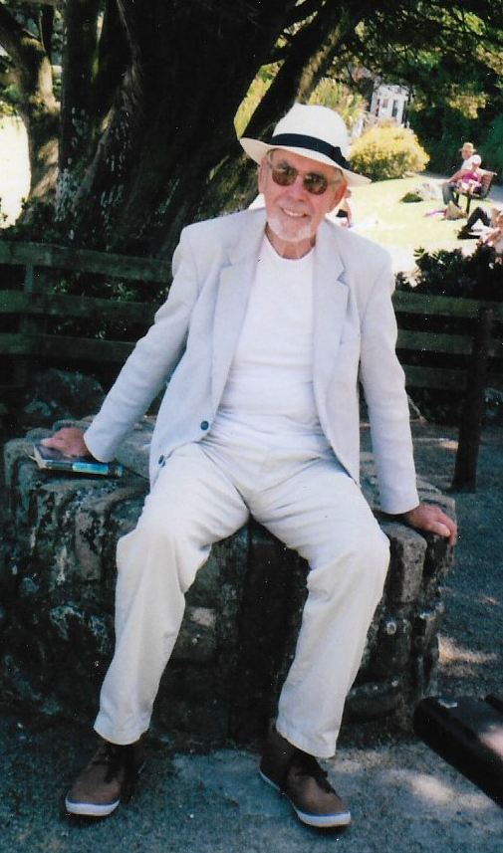

Humanist Celebrant
Ian Willox
01865 589 663
ian.willox@humanistceremonies.org.uk

Humanists UK
39 Moreland Street, London, EC1V 8BB
020 7324 3060
www.humanism.org.uk

Funeral Director
A.L. Sole & Son
Chipping Norton

ENTRANCE
Frédéric Chopin's "Raindrop" Prelude, Op 28, No. 15
Photo montage

OPENING WORDS
Good morning everyone. We’re here to celebrate the life of Dr Barry Randolph Martin who died at Middlletown Grange Care Home on 25th August aged 81.

INTRODUCTION
I should introduce myself. My name is Ian Willox. I’m a celebrant for Humanists UK. Barry was an ardent socialist and atheist. His family have asked for a Humanist funeral – a non-religious funeral. That doesn’t mean anti-religious. This is a ceremony for everyone – including those with a religious faith.

THOUGHTS ON LIFE AND DEATH
With or without religion, one of the purposes of a funeral is to remember – so that Barry lives on in our memories at least.

So let’s remember…

TRIBUTE
I never met Barry. So I’m going to say very little. Because he has a family who are going to do the job. Starting with his wife Philippa. Flip…

PHILIPPA (with EMMA):
As many of you know, Barry and I have always been keen theatregoers. We have especially enjoyed Shakespeare. These lines are spoken by Cleopatra as Antony is dying. I said them to Barry on Saturday. I want to say them one more time to him and to you.

Noblest of men, woo’t die?
Hast thou no care of me? Shall I abide
In this dull world, which in thy absence is
No better than a sty? O, see, my women,

The crown of earth doth melt. My lord!
O withered is the garland of war,
The soldier’s pole is fall’n: young boys and girls
Are level now with men. The odds is gone,
And there is nothing left remarkable
Beneath the visiting moon.
Act IV, scene XV, Antony & Cleopatra – William Shakespeare

As you’re going to find out – music played a big part in Barry’s life. You saw Emma playing Chopin’s Raindrop Prelude at the start of today’s ceremony. We’re going to follow it up with something equally beautiful – Debussy’s Clair de Lune.

Clair de Lune – Debussy

Barry’s daughter Clare has written the Eulogy. Her brother Jeremy is going to read it. Jeremy…

CLARE’S EULOGY READ BY JEREMY:
Barry was born on 17 September 1936 in a bedroom of 92 The Green, Morden, Surrey, and named after the little-known band leader, Barry Martin, by his dance music-loving mother, Phyllis. During the war, the family moved around a lot because of Barry’s father, George’s postings in the Navy. First they went to Sheerness and then Edinburgh, which was a happy time for him and his brother, and he instantly made a group of friends he called the ‘Grierson Gang’. He spent most of his time outdoors catching crabs, mussels and winkles. After the war, they moved back to Morden where Barry learnt to help his father and grandfather with gardening and DIY, both of which became enduring hobbies. Later on, when he was a father himself, Barry would take great pleasure in designing gardens each time the family moved house. He was also diligent in his garden maintenance, always keeping everything beautifully neat and tidy, just like himself. He always wore a shirt and tie, even when he was mowing the lawn!

In 1947, when he was 11, Barry won a scholarship to King’s College School in Wimbledon. This was when he started to develop his love of cricket and rugby, which he shared with his close friends John Wainwright and Dave Ferebee, who also taught him to play chess. Barry had his first trip to the Oval that year, and could still list the names of the entire team (in batting order) in his seventies. This is just one of many examples of his extraordinary memory: everyone who knew him well got used to him reciting entire bridge hands (not always the most entertaining conversation topic!) Even when his health deteriorated in later life, he would still regularly recount all of the names of the Grierson Gang.

Barry was given his first astronomy book by his father when he was 11. It was called ‘The Nature of the Universe’ by Fred Hoyle. This led to a lifelong interest in astronomy and science, which grew into his career, and one day he even had the chance to give Fred Hoyle a lift from Cambridge to Oxford. He was never happier than in the days in the Appleton laboratory in his early 30s where he worked on exciting satellite projects including Ariel 5 and IRAS. Many of his colleagues from that time became very close friends with whom he played cricket and bridge, and whom he continued to see until his final illness prevented him from doing so a few years ago.

In 1948, Barry’s father became chairman of the local Conservative party and a local councillor. Much of the work involved housing the many people who had lost their homes during the war, and this was to sow the seeds for Barry’s subsequent involvement in the Labour party. He always said that his parents’ politics were actually very socialist. Like his father, Barry undertook a lot of voluntary work, always taking an active role in PTAs and later becoming a governor of various schools. After he retired in 1996, Barry had more time to think about politics, and wrote some compelling letters that were published in the Guardian. Some of them will be on display at lunchtime.

In 1955, the family moved to East Grinstead and Barry won a place and a State Scholarship to read mathematics at Merton College, Oxford. He enjoyed his university days enormously. Early on he was selected to play rugby for the 1st XV, and it was at Oxford that he discovered his taste for beer. He always liked to tell the story of his first tutorial, which only lasted a few minutes because his tutor decided to take the students to one of the local pubs instead. Despite this, Barry valued education very highly. He went on to do a D. Phil, under the supervision of John Reid at Sussex, which he dedicated to Mr Eastcott, the surgeon who saved his life in his 20s. He always ensured that both children had the best educational opportunities he could provide. In fact, both of us followed precisely in his footsteps, doing Oxbridge mathematics degrees followed by D. Phils.

Barry’s cousin Colin went to university the same year, and they became great friends when they worked together on tough labouring jobs during the vacations. Barry’s first holiday job, in December 1955, was much less arduous though, at the East Grinstead Post Office. He wrote about it later in his life, in his words:

“On my first day there I walked through the door and down to where the sorting was being done. I looked down and saw this incredibly wonderful girl. She looked up and said ‘Hallo, I’m Flip, what’s your name?’ We were married five years later when she was 21 and I was 24. I was so lucky that Mum and Dad had moved to East Grinstead for otherwise we would never have met.”

Before they were married, he pursued Philippa relentlessly. Every time he came back for the university vacation, she had a new boyfriend that he had to displace. He first proposed to her when she was 17 and still at school! For their honeymoon, Barry chose a surprise destination, which was the Isles of Scilly. Philippa was rather disappointed at the time as she was hoping for something much more exotic, but of course this started their enduring love affair with Cornwall. All of the family spent many happy times there, especially at Pit Pry in Zennor, and Barry took huge pleasure in sharing that home with friends and family. Barry used to love surfing, which is something that he taught all of the family to enjoy, especially his eldest grandchild Adrian who is now an excellent surfer. In 2010, Barry and Philippa took the whole family back to stay in the Isles of Scilly to celebrate their Golden Wedding, a memory that we all treasure.

Throughout his life, Barry always said how lucky he was and what a wonderful life he and Philippa had shared. He was loving, kind and an absolute gentleman, who was hard-working, scrupulously honest and utterly dedicated to his family, friends and work colleagues. He was a keen sportsman and an accomplished handyman who loved playing bridge and had a strong sense of humour. As a child of rationing, he was always thrifty, yet incredibly generous, and always the first to buy a round in the pub.

Philippa was the absolute love of Barry’s life, and she always cared for him with immense love and dedication. In his later years she encouraged him with all sorts of activities to stimulate his brain, such as his daily Sudoku puzzles in the Guardian, arts and crafts activities, iPad games, and above all music, regularly taking him to local singing sessions. Even up to a few weeks ago it was music that continued to move him the most. He loved listening to the dance band music of his youth, and took to whistling an amazing variety of tunes at his home in Middletown Grange. He was generous right to the end, still treating us all to lovely smiles and happily foot-tapping while we sang to him, slowly crucifying some his favourite songs. We have been incredibly lucky to have him as our father and we will do our utmost to live up to our memories of him.

Thank you

Now I have great pleasure in introducing some of Barry’s grand children – Joe, Emma and Clarisse – who are going to perform Fly Me To The Moon.

Fly Me To The Moon

Time for the grandchildren to remember Barry…

GRANDCHILDREN

Barry’s family are firmly of the opinion that they wanted a singalong as part of today’s ceremony. The first song is All My Loving. You’ll find the words in your order of service. And because I have such an awful singing voice, Jeremy is going to lead the singing.

All My Loving – Beatles

Barry and Philippa joined a project in Chipping Norton called Lights Up. As part of that project Barry recorded a reading of Edward Thomas’ poem Adlestrop. This is what is sounded like:

Adlestrop read by Barry
Yes. I remember Adlestrop—
The name, because one afternoon
Of heat the express-train drew up there
Unwontedly. It was late June.

The steam hissed. Someone cleared his throat.
No one left and no one came
On the bare platform. What I saw
Was Adlestrop—only the name

And willows, willow-herb, and grass,
And meadowsweet, and haycocks dry,
No whit less still and lonely fair
Than the high cloudlets in the sky.

And for that minute a blackbird sang
Close by, and round him, mistier,
Farther and farther, all the birds
Of Oxfordshire and Gloucestershire.
Edward Thomas

Barry as part of a Lights Up production.

QUIET REFLECTION
We’re coming to the end of this celebration of Barry’s life. But before we do we’re going to pause for a moment of reflection. A chance for you to digest all you’ve heard. A chance for you to recall your own memories of him. A chance, if you wish, to pray silently. Or just a chance to see Barry jamming with his grandson Joe:

Stormy Weather – Barry and Joe

Time for the next singalong. Jeremy please. This time it’s the White Cliffs of Dover. Once again the words are in your order of service.

White Cliffs Of Dover – Vera Lynn

COMMITTAL
Just as we welcome a child into our lives we must say goodbye to those who leave us. This celebration of Barry’s life is complete. It’s time to say farewell to him. This may be difficult but it is important. I hope the memories we’ve talked about here may give you some comfort.

FINAL FAREWELL
Our atoms and molecules come from the earth;
Are ordered by ancestry;
Are fired into life by union;
Are sustained by the earth and powered by the sun;
And return to the earth when life ends.
John Stuffin

Dr Barry Randolph Martin. Son of George and Phyllis. Brother to Jim. Husband to Philippa. Father of Jeremy and Clare. Grandfather to Adrian, Alex, Clarisse, Emma and Joe.

We commit your body to be cremated. Rest in the hearts and minds of all you love and all who love you.

CLOSING WORDS
We’ve celebrated Barry’s life. We’ve said our goodbyes. But we have our memories. And the rest of our lives to remember.

If you want to share those memories – or just some refreshment – you’re warmly invited to join the family at Studley Wood Golf Club . You’ll find details in your order of service.

As you leave you’ll see that you can make a donation in Barry’s memory to Oxford Hospitals Charirty. Again you’ll find details in your order of service.

Please take good care of yourselves and each other.

Thank you for coming.

EXIT
In The Mood – Glenn Miller
Photo montage

