A CELEBRATION OF THE LIFE OF

Dr VALERIO AUGUSTO LUCCHESI
10th April 1927 – 2nd September 2018

held at
Corpus Christi College Chapel
and
the Memorial Chapel, Oxford Crematorium
on 24th September 2018

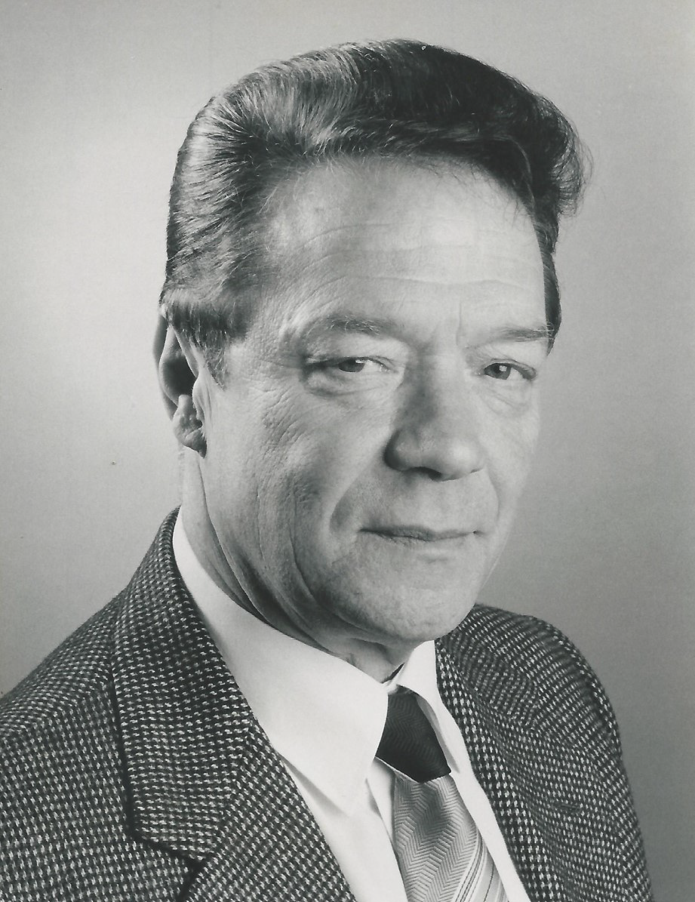

Humanist Celebrant
Ian Willox
01865 589 663
ian.willox@humanistceremonies.org.uk

Humanists UK
39 Moreland Street, London, EC1V 8BB
020 7324 3060
www.humanism.org.uk

Funeral Director
Jerrams Brothers

ENTRANCE
Francesco Geminiani – Concerti Grossi Op 7

OPENING WORDS
Good morning everyone. We’re here to celebrate the life of Dr. Valerio Augusto Lucchesi who died, aged 91, with his wife Joyce by his side, on 2nd September.

INTRODUCTION
I should introduce myself. My name is Ian Willox. I’m a celebrant for Humanists UK. Valerio’s wife Joyce has asked for a Humanist funeral – a non-religious funeral. That doesn’t mean anti-religious. This is a ceremony for everyone – including those with a religious faith.

Which, given this rather august location, is probably a good thing.

I’d like to thank the acting chaplain, Canon Mountford, for guiding me through the intricacies of this chapel.

THOUGHTS ON LIFE AND DEATH
With or without religion, one of the purposes of a funeral is to remember – so that Valerio lives on in our memories at least.

So let’s remember…

TRIBUTE
We’re going to start with a poem. A poem Valerio wrote himself. Prompted, I suspect, by a seminal experience he had as an adolescent.

The poem will be introduced by Professor Giuseppe Stellardi. He’ll read the Italian original of the poem. And I’ll try to help with an English translation. Giuseppe…

Prof. Giuseppe Stellardi:
This is how Valerio introduced his poem:
There are events in our lives that rise up in our memory without any prompting, almost – one could say – miraculously, on the occasion of their anniversary. One such is 24th October 1943, a crucial year in the war and my adolescence. That night Pistoia suffered the first and most disastrous of five bombing raids, during which at least five hundred houses were destroyed and several historic buildings and works of art seriously damaged. Over a hundred and fifty people lost their lives.

This poem is not only a revocation of that tragic night but also a homage to their memory. It is sad but only natural that, after sixty-six years, the number of those who witnessed the event is now much reduced. Nevertheless I hope that if some of them have occasion to read these lines they will find, if not enough poetry, at least a reasonably faithful mirror of their own memories and the feelings they had then and have today.

24 Ottobre 1943
Basta un lampo di cielo: et lux facta est.
In queste notti di autunnali brume
la memoria si illumina a un tratto
come l’oscura cripta di una chiesa
rifolgorata da un notturno lampo.

A lightning flash in the sky is enough: and there was light.
In these nights of autumn mists
Memory is suddenly lit up
Like the dark crypt of a church
Lit by lightning in the night.

Ecco scender dal cielo
un livido chiarore di bengala
che filtra dalle imposte e crea sui muri
un lento risalire e scender d’ombre.

And now down from the sky drifts
A deathly glow of flares
That filters through the blinds and on the walls
Creates shadows that slowly rise and fall.

Ruota in alto una ridda
di invisibili dèmoni. A ogni fischio
La terra urla, si contorce e avvampa.

Up above whirls a noisy dance
Of invisible devils. At every whistling hiss
The earth screams, writhes and catches fire.

Ed ecco il vacillare della scala
che si oppone alla nostra ansia di fuga
verso rifugi inutili - e ci salva.

And now the staircase shakes
Preventing our anxious flight
To useless shelter - and saves us.

(All’alba lungo i margini anneriti di fumosi crateri
i volti polverosi e sbigottiti
di chi sicuro d’essere credeva
guardan con gli occhi chiusi verso il cielo).

(At dawn along the blackened edges
Of smoking craters
The terrified faces covered in dust
Of those who thought they would be saved
Gaze skywards with closed eyes).

In queste spente notti d’autunno
solo il ricordo è luce, l’alba
lontana. E vano il domandarsi
perché il destino ci precluse il varco.

In these dark autumn nights
Only memory sheds light, dawn is
Far away. And it is useless asking
Why destiny barred our passing.

Just for the avoidance of doubt, 16 year old Valerio was being bombed by the RAF who - though aiming for a nearby railway line – were, as a matter of policy, deliberately targeting the associated civilian areas. Which makes Valerio’s decision to learn English and move to Britain more nuanced.

They were nuanced times. Valerio’s father Mario worked at the town hall. Technically a blackshirt. The actual black shirt was torn off when he got home for lunch. Because under it beat the heart of an antifascist. But Mario had to feed his family.

Valerio’s mother Evelina seems less able to dissemble. Joyce told me that when German soldiers stole Evelina’s bike she stomped down to the SS Headquarters, tore a strip off them – and got her bike back.

These were dangerous times. Valerio hung out with the partisans. Which did not please his mother.

Towards the end of the war he was rounded up with all the other young men to be used for forced labour. Valerio had previously befriended a couple of Austrians. He – very illegally – translated Radio London transmissions for them. Thanks to them he ended up being surreptitiously returned home. A lucky boy.

But he earned that luck. In the chaos of wartime he had to more or less educate himself. He did a good job (though he was never great at Maths). He was accepted by the University of Florence where he chose to take his doctoral degree in English and write his dissertation with a thesis on Wordsworth’s Prelude. Not bad for a boy who learnt a lot of his English from British and American troops stationed in Pistoia during the last stages of the Italian campaign.

I say boy. When Valerio and his mother went to Florence to enrol him he looked too young to be a student. His mother, also young looking, was presumed to be the undergraduate.

His doctoral thesis was awarded full marks – which qualified Valerio as assistente volontario in the English faculty of Florence – but no funds for research were available.

Funds were hard to come by in post war Italy. Valerio’s supervisor recommended him to Edinburgh University for a temporary post as Lector teaching Italian instead of the subject of his degree – which was English. He took the job.

And set in course a chain of events that allowed him to meet Joyce. A complicated chain of events so bear with me.

Joyce was a first year student studying French and Italian at Manchester University. Late for a lecture. Rushing up the steps with an armful of books. Valerio opened the door on her unexpectedly. She dropped the books. And thought “Wow!”. Then “Forget it. He’s a teacher.” So that was that. Valerio didn’t notice her.

In third year Joyce signed up for a work camp in Southern Italy. Her father was not keen and suggested she consult her teacher for advice. She went to Valerio’s room and explained her father’s apprehensions. Valerio told her she had nothing to fear – except wolves. “The two legged or the four legged kind?” Joyce asked.

Then Valerio noticed her.

So basically Joyce’s father is responsible for her and Valerio getting together.

They were married on 24th June 1967 in Joyce’s home town of Yeadon in Yorkshire. A memorable date. The anniversary of Joyce’s sister’s wedding. And Joyce’s sister’s birthday.

But it slipped Valerio’s mind. He was also booked to be an external examiner at Edinburgh University on the same day.

He managed to get the second marking delayed. He and Joyce married. Then shot up to Edinburgh for the marking. They planned to follow that with a honeymoon excursion round the northern coast of Scotland. They got as far as Inverness. And gave up. Defeated by the glories of the Scottish summer.

They headed south. To Oxford. To a temporary apartment in Crick Road. Where they have lived ever since. 51 years of temporary.

Time for Valerio’s friend and colleague, Professor Peter Hainsworth, to pick up the story.

Professor Peter Hainsworth:
The SubFaculty of Italian when I joined it in 1979, had at its core a professor, Cecil Grayson, and four University Lecturers – myself, the newcomer, and then John Woodhouse, David Robey, and Valerio Lucchesi. We were all fairly wide ranging in the courses we were prepared to teach, but Valerio was the recognized specialist in the important area of the History of the Italian Language and all students who wanted to study the subject were automatically referred to him. They were always received with great good grace and given the sort of personal attention that Valerio gave to all his students.

The History of the Language was his principal field of research, the results of which were some important and substantial articles, particularly on the Medieval and Renaissance periods. Probably the most important of them is the long 1971 article on aspects of the Italian verb, very much a specialist topic, obviously, but one which Valerio treats not just with remarkable thoughtfulness and learning, but with equally remarkable clarity. Not for him here or anywhere else in his writings any fashionable jargon or highly technical language. At the same time he was anything but a stick-in-the-mud, but rather a scholar who brought to bear the informed, intellectual attention that he knew his subject required.

Valerio was never a linguistician in a narrow sense. He had after all begun his academic career with a thesis on Wordsworth. As the years went by, he became more and more interested in Dante, particularly the Divina commedia. His work on Dante is grounded in his linguistic concerns and explores Dante's poetic techniques and practice in a way that the usual direct focussing on Dante's thought and imaginative genius had often precluded. Not that Valerio sees textual analysis as an end in itself. For him linguistic and stylistic dissection of the actual text is inseparable from study of its social, political and intellectual hinterland, not to mention contemporary and previous language use outside Dante. This is especially evident in the articles he wrote about the canto of the heretics in the Inferno which include some of his most stimulating and convincing critical writing. And then his interest in language and style is also always related to aesthetic issues, to the poetry of Dante, in some ways in the manner of Benedetto Croce but with a more generous view of what that poetry might consist of. His approach is more generous too than that of those many critics who are determined to pin down Dante’s allegory, as if it were a kind of code that has to cracked. Valerio is always alive to the openness of metaphor, to the richness of Dante’s imagery, and techniques, not all of which he felt could be convincingly described as directed towards conveying meaning. Dante, he thought, could go in for ornamentation, much as some of the artists working on say Notre Dame also did. At the same time Valerio has no truck with the idea that a poetic text can mean whatever you want it to mean. Again the intellectual robustness and independence of mind are impressive.

Overall as a scholar and critic Valerio worked within the sort of materialist-humanistic aesthetic framework that used to be associated with the intellectual left in Italy. To cite one facet of his thinking which perhaps came over more in conversation than in his writing, Valerio thought that Dante could get things wrong poetically - unlike I would say almost all other Dantists for whom every word he wrote is marked by greatness. After all Horace thought Homer nodded now and then, and Valerio, as a humanist critic resisting the sirens of transcendence, thought something similar about Dante.

I got to know Valerio much better than before initially through the Oxford Dante Society, the scholarly society established in the later 19th century by some of the greatest Dantists of the time. Valerio was secretary from (I think) 1986 to 2006. Secretary meant running the thing - finding speakers, getting other members to host meetings in their individual colleges, writing up the minutes, and so on. In other words the Secretary was a bit like the Secretary of a Communist Party, the boss in all but name. Valerio was an excellent secretary, thoughtful, punctilious, and in control, though with discretion that meant that most other members were not really aware that he was actually the one pulling the strings.

I saw Valerio regularly over the last ten or so years. We established a routine of meeting for lunch in the Rose and Crown in North Parade at least once a term. We would talk about Dante of course, but also about much else, not least the state of the world. Valerio always had distinctively individual but cogent things to say, and always from a strikingly global perspective, not from a simply European, let alone Italian or English one. He was of course a pessimist, but a healthy one. I shall miss enormously seeing his always smartly turned out figure emerging from Norham Road, his warm smile of greeting and the way he took my arm to escort me safely through the traffic of Banbury Road, shaking his head a little and asking me quizzically what I'd been up to since we last met. I shall miss even more the conversations that followed.

Let’s pause for some music. Chopin’s second piano concerto.

Chopin – 2nd Piano Concerto, 2nd Movement

Now it’s the turn of another friend and colleague, Professor Brian Harrison, to remember Valerio.

Professor Brian Harrison:

Time for more music. Serenade for Strings. Attributed to Haydn.

att. Haydn – Serenade for Strings, Opus 3, No 5

We come to the final tribute. From Professor David Clarke. Valerio’s closest friend.

Professor David Clarke:

QUIET REFLECTION
We’re coming to the end of this celebration of Valerio’s life. But before we do we’re going to pause for a moment of reflection. A chance for you to digest all you’ve heard. A chance for you to recall your own memories of him. A chance, if you wish, to pray silently. A chance to listen to a piece of music that Valerio liked so much – he wanted it for his funeral. Mozart’s Ave Verum Corpus.

Mozart – Ave Verum Corpus
We have remembered Valerio as an adolescent, as a poet, as an academic, as a husband and as a friend. A lot of memories. May you have many years to keep those memories alive.

And while you remember, we will be taking Valerio to the Memorial Chapel at Oxford Crematorium for his cremation.

And as we do, we’re going to play Valerio’s favourite piece of music – Chabrier’s Habanera.

As you leave you will see that you can make a donation in Valerio’s memory to the British Heart Foundation. You’ll find details in your order of service.

Please look after yourselves and each other.

And thank you for coming.

Emmanuel Chabrier – Habanera

MEMORIAL CHAPEL - COMMITTAL

Greig – Holberg Suite

COMMITTAL
Good afternoon. Just as we welcome a child into our lives we must say goodbye to those who leave us. This celebration of Valerio’s life is complete. It’s time to say farewell to him. This may be difficult but it is important. I hope the memories we’ve talked about at Corpus Christi College Chapel may give you some comfort.

FINAL FAREWELL
Our atoms and molecules come from the earth;
Are ordered by ancestry;
Are fired into life by union;
Are sustained by the earth and powered by the sun;
And return to the earth when life ends.
John Stuffin

Doctor Valerio Augusto Lucchesi. Son of Evelina and Mario. Brother to Anna. Husband to Joyce. Uncle to Rossana. Great Uncle to Ariana. First and last Fellow and Tutor in Modern Languages at Corpus Christi.

We commit your body to be cremated. Rest in the hearts and minds of all you love and all who love you.

CLOSING WORDS
We’ve celebrated Valerio’s life. We’ve said our goodbyes. But we have our memories. And the rest of our lives to remember.

Please take good care of yourselves and each other.

Thank you for coming.

Greig – Holberg Suite

