A CELEBRATION OF THE LIFE OF

ENID ASHTON
11th October 1922 – 6th February 2018

held at
Banbury Crematorium
on Wednesday 14th February 2018

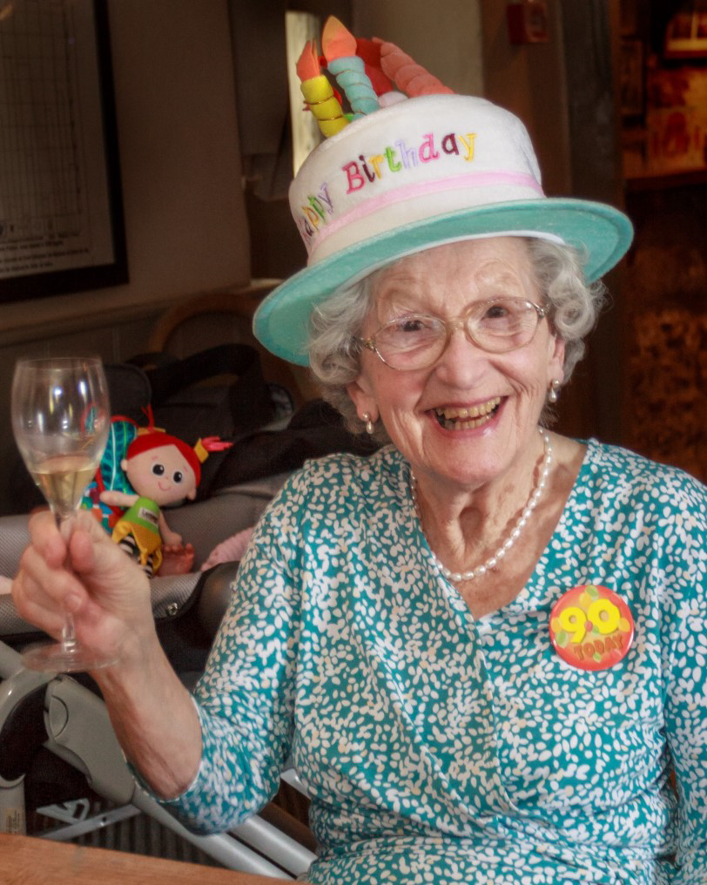

Humanist Celebrant
Ian Willox
01865 589 663
ian.willox@humanistceremonies.org.uk

Humanists UK
39 Moreland Street, London, EC1V 8BB
020 7324 3060
www.humanism.org.uk

Funeral Director
Sole & Son
Chipping Norton

ENTRANCE
9 Million Bicycles – Katie Melua

OPENING WORDS
Good afternoon everyone. We’re here to celebrate the life of Enid Ashton who died at Langston Care Home on 6th February aged 95.

INTRODUCTION
I should introduce myself. My name is Ian Willox. I’m a celebrant for Humanists UK. Enid’s family have asked for a non-religious funeral. That doesn’t mean anti-religious. This is a ceremony for everyone – including those with a religious faith.

THOUGHTS ON LIFE AND DEATH
With or without religion, one of the important things a funeral can do is remember – so that Enid lives on in our memories at least.

So let’s remember…

TRIBUTE
Enid was the only child of Fred and Lily Stott. She was born in Blackley (pron “Blakeley”) near Manchester. Fred was a tobacconist.

Enid was bright. She was educated at Middleton Grammar School then started work for Barclays Bank. When World War Two arrived she joined the Womens Royal Naval Service. Trish thinks partly to get away from her mother Lily who was “a bit of a matriarch”.

But Enid was also very proud of her service in the WRNS – and I get the impression she had a good war.

Enid’s parents knew John’s parents – and thought they would make a good match.

They were right.

John and Enid were married at Middleton Parish Church in June of 1948.

They moved to Newcastle upon Tyne where John ran a newsagents.

The children - Patricia and Jonathan - came along.

Then the family moved to Stoke on Trent and John got a job at Lewis’s.

When Trish was about 17, John and Enid bought a greengrocers near Stoke on Trent. They ran the greengrocers until their retirement in the late 80s.

Enid and John liked to travel. They holidayed in Italy, Croatia, Austria – all over Europe – until John’s death about 15 years ago.

Enid moved to Chipping Norton to be nearer Trish. Two years ago, having become frailer, she moved to The Langston Care Home in Kingham.

Trish says she was happy there. She carried on painting in oils and watercolours until cataracts made it impossible. Her work was exhibited in the dining room.

Her other pastime appears to have been rechristening everyone, including her carers. She did not like to be corrected. When Trish tried to tell her that someone’s name was Norma she would say: “I think you’ll find Patricia that she’s called Laura”.

That’s not to say Enid didn’t have a sense of humour. Like her mother she was a feisty woman who knew her own mind. But with a twinkle in her eye. When a carer was trying to persuade Enid to take some medicine she didn’t like by suggesting she pretend it was something she that did like – like whisky – Enid fixed her with a stare and said “I’m not stupid you know.”

Here’s Enid’s son Jonathan to tell you more:

JONATHAN ASHTON:
Mum, Mother, Gran, Great Gran, Little Gran, Enid - we all knew Mum and related to her in different ways. We all had something in common, however, that is we all thought the world of her and respected her as a lady. I am sure Tish will recall that one of Mum's consistent mantras was “mind your manners”. I am sure that is something that most of her grandchildren will also recall.

Mum was for the most part a very conventional sort of lady with traditional family values. She had a pretty keen sense of humour I am sure we can all recall instances where we have had really good laughter. As Ian pointed out she would often unwittingly generate laughter herself by getting names or places mixed up or by inventing names and being utterly convinced she was correct.

She quite enjoyed music and sometimes a sing song and she particularly liked it when James played the piano for her.

Mum was especially fond of her grandchildren and great grandchildren, even if she couldn't always recall the names correctly – come to think of it that isn't one of my strong points either – I must have got that from her. She frequently recollected her meetings and especially loved talking about the great grandchildren and how they made her laugh.

I have mentioned family but I am absolutely certain that Mum would like me to thank the staff at the Langston whom she became very fond of, and who in return became very fond of her. I think she did in fact regard quite a few of the staff as friends, though once again I am afraid she did get their names a little mixed up – but I think they would agree that didn't really matter because she just invented other names she could remember!

I think Mum had for the most part a very happy life but the one thing that was really missing for her in the latter years was of course Dad. If there is a heaven I am sure you would all join me in wishing that she became reunited with him there.

QUIET REFLECTION
We’re coming to the end of this celebration of Enid’s life. But before we do we’re going to pause for a moment of reflection. A chance for you to digest all you’ve heard. A chance for you to recall your own memories of her. A chance, if you wish, to pray silently.

When I Fall In Love – Nat King Cole

COMMITTAL
Just as we welcome a child into our lives we must say goodbye to those who leave us. This celebration of Enid’s life is complete. It’s time to say farewell to her. This may be difficult but it is important. I hope the memories we’ve talked about here may give you some comfort.

FINAL FAREWELL
Our atoms and molecules come from the earth;
Are ordered by ancestry;
Are fired into life by union;
Are sustained by the earth and powered by the sun;
And return to the earth when life ends.
John Stuffin

Enid Ashton. Only child of Fred and Lily. Wife to John. Mother of Patricia and Jonathan. Grandmother to Ben, Tim, Richard, Philip and James. Great grandmother to Isabelle, Charlotte, Eleanor, Grace, Abigail, Abigail, Jacob, Lara, Elise and Isaac. We commit your body to be cremated. Rest in the hearts and minds of all you love and all who love you.

CLOSING WORDS
We’ve celebrated Enid’s life. We’ve said our goodbyes. But we have our memories. And the rest of our lives to remember.

If you want to share those memories – or just some refreshment – you’re warmly invited to join the family at Trish’s. You’ll find details in your order of service.

As you leave you’ll see that you can make a donation in Enid’s memory to Help for Heroes. Again you’ll find details in your order of service.

For the exit music Enid’s children have chosen a favourite of hers – “Pablo Santorini”.

Please take good care of yourselves and each other.

Thank you for coming.

EXIT
Pencil Full Of Lead - Paolo Nutini

