Ida Rado

Date of birth 01/07/1910

Date of death 04/06/2015

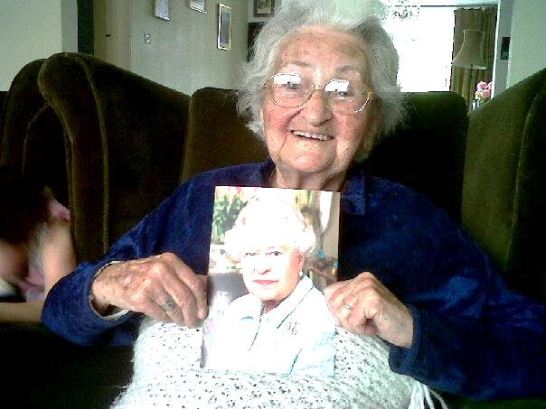
Ida Rado with her card from the Queen in 2010
Welcome and introduction

Welcome to you all here today to honour and celebrate the life of our aunty Ida, Idka Naney, great-aunt, and friend, Ida Rado, or in Hebrew, Yehudit bat Menachim Israel ve Rahel Leah, who has died peacefully a few weeks before her 105th birthday.

Idka’s family was central and fundamental throughout her long and eventful life. There are four generations of our family here today, from the youngest babies, to the oldest niece, Judy.

The painting – view from train, 1945, painted by Ida Rado in 1980s

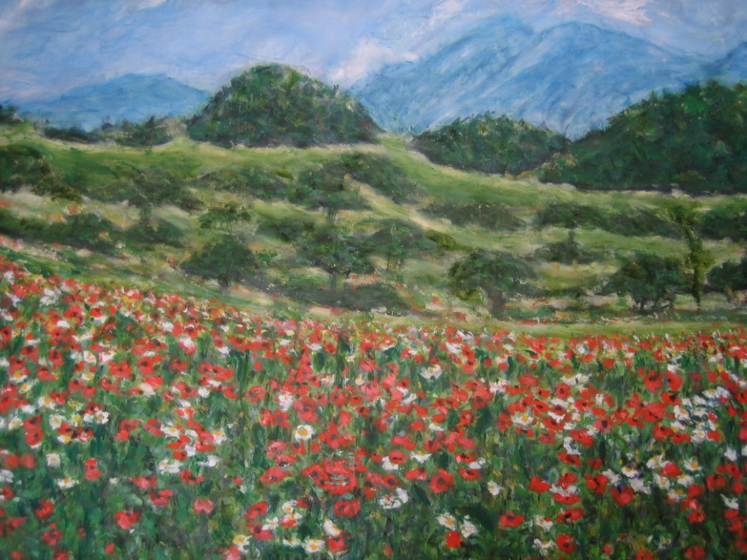

We’ve brought this painting here today because it sums up for us Idka’s will to live and her powers of survival. Idka painted it when she was much older, in her early 70s, when she also painted some of her memories of the war.
It’s a memory of an incident that happened shortly after Liberation. Idka and Teri had spent the last 3 months of the war in a Czech village, staying with a family in their barn, after having escaped from the death march.
Despite the family’s entreaties to stay in their town, they were determined to return home. After waiting for a train for several days, the trains were very crowded, there were no seats, so they climbed onto the roof of the train.
There was a rainstorm and they got completely drenched, but after the storm the sky cleared and they looked around and saw this scene - the clouds, the mountains, the forests and a beautiful wildflower-filled meadow.
It was the first time they felt alive again and full of hope. The relief of survival. Their re-birth.

Idka’s story by Sylvie Summer, niece

Most of you who have sat for any time with Aunty Ida will have heard her talk about her life. About 7 years ago I helped her to write down her memories of her childhood and up to her liberation after the war. As she herself said, ‘I am left here to tell the story’.

She always described herself as the weak, sickly child of the family, who sat on her father’s knee. The incident that ended her childhood was the loss of her eye, which affected her view of herself at a time when a woman’s worth was determined by how she looked. Idka married in a joint wedding with her older sister, Teri. We know that her experiences during the Holocaust defined the rest of her life, but that was one year out of more than a century. She was a refugee for the second time when she and Alexander left Hungary after the Hungarian revolution and came to England in 1957; that was when Monica and I first met her. We were excited when we knew Aunty Ida and Uncle Alexander were coming to stay with us after leaving Hungary. What really impressed us, though, was the trunk that arrived a few weeks later. It was filled with treasures: for us little girls there were dolls in Hungarian costume with china faces and stuck-on hair that came off if you tried to comb it. Beautiful lace table cloths, cut glass bowls that sparkled, nothing like we had at home.
Later on when they moved to a flat in Neasden Lane, and Aunty Ida had started sewing evening dresses for fat ladies, she would save the bejewelled off-cuts for me, and sometimes, if we asked nicely, she made our dolls clothes. She even made clothes for little angels at her first English Christmas when Judy was here.

In the 1960s Idka continued to look after family – her niece, Agi, came to live with her for a while and she looked after her sister Teri while Judy was studying in America. When she retired Idka started painting and this was the happiest time of her life. The last few years after Pishta died have been hard for her and for us – it has been her drive, her determination, her effort and probably her instinct for survival that has kept her going for nearly 105 years. And I think she died in the way she wanted: quickly and without pain, with us by her side.

We’ll now hear Tributes from family

Tribute from Cochavi family in Israel-great nieces and great nephews

Dear Family,
From afar and with great sadness we are parting from Auntie Ida. Idka was a part of our grandfather Noah’s generation and was the last woman of that generation that lived in the 21st century.
For our father, who had no siblings, Idka was like an older sister, and he loved her like one. Despite the physical distance between them, they talked to each other often, and Idka always offered her assistance when he needed it, especially in his last years. We will always be grateful to her for allowing him to live with dignity to his last day.
And for us, the ‘Kibbutznik' kids - Idka was the sweet but powerful Auntie from London, who left us nice memories of her visits. She was always interested in our lives, and caught up with our paths and our place in the world. We are all grateful for her generosity to our family over the years.
Aba's love and appreciation to Idka was passed on to us in a strong and vivid way. We were so happy they got to talk to each other on the phone just a day before he passed away. He was too weak and wasn't able to talk, but he heard her say her goodbyes, and the tears rolled down his cheeks. It was a very touching moment.
Idka saw some pain and suffering in her long life, especially in her young days, but she also had beautiful times with her husband Pishta, and her devoted family around her.
Five years ago we gathered to celebrate Idka’s 100th birthday. It was an unforgettable party, especially for Idka herself. We all made a wish back then to get together again in 5 years to celebrate her 105th birthday. And now we are all together again, in different parts of the world, to say our last goodbye.
In the gathering five years ago, Idka’s last words to all of us were - "stay together. The world is a hard place to live in, and it is the family that keeps you going. Please stay together as a family", she asked.
We promise we will do our best.
We will always remember you with love.
Rest in peace Auntie Ida.
From all of us, the Cochavi, Gold and Ross families.
Eli and Jesse’s tributes- great-nephews
Tribute from Eli
I want to say a few words about Auntie Ida’s eye.
The story of Auntie Ida losing her eye is just the first episode of many, many difficulties in her life. But I think it is the first thing I knew about her. As I have gotten older I have found myself thinking more about what it could have been like to survive Auschwitz and the 1956 revolution, to emigrate as an adult, and to live 105 years. But now, I want to remember her eye. Not the glass one, but her good eye.
I know that Auntie Ida was terrified about losing vision in her good eye, and with good reason. But despite this, she sewed for a living, painted in her retirement, and then spent long hours watching Hungarian cable television and reading the Jewish Chronicle. Her eye, doing double duty, scarcely had a moment's rest. Neither did the rest of her.
I heard that Auntie Ida was self-conscious about having only one eye. But now I can picture a self-portrait that she painted where she is facing the viewer calmly and directly. Her eyes look subtly different from each other in the painting but to me, this doesn't seem self-conscious. She isn't hiding anything or pretending things are different. Instead, to me, the portrait looks honest and confident, which are two of the qualities that I will remember about Auntie Ida.
I remember when Auntie Ida herself told me that she only had one eye. I was visiting one summer and staying at her house. She warned me that I shouldn't be surprised if I saw her in the morning without her glass eye. I told her that I already knew she was missing an eye and that it wouldn't upset me. That trip, we watched the 1998 World Cup finals together in her bed and after which she told me the story about leaving her town as a teenager to seek treatment for her eye and then coming back alone in the dark and hearing wolves in the hills. For Auntie Ida, it was one of many terrifying journeys. But after opening up about her eye, she began to talk about much more. Because her English was so much better than my grandparents', and because we simply had the time, I (and I think this goes for most of us grandchildren) got to know her better than anyone else from her generation.
Auntie Ida's eye worked ... and worked and worked and worked for 105 years. It saw hell on earth and the destruction of her entire life, but it also saw the rebuilding of a life, and the regrowth of her family. She lived to see so much. Her eye was an incredibly resilient part of an exceptionally resilient person. And it is this resilience that I will always remember when I think of Auntie Ida.
Tribute from Jesse, great-nephew

When I think of Auntie Ida, two things come to mind: eating and death. My earliest memories of Auntie are sitting at her table for lunch. Not just any lunch, but a feast of soup, chicken paprikash, cucumber salad and other Hungarian delights, followed of course by tea and cake. When a plate started to look empty or someone's pace began to slacken, she would entreat us to "eat, eat." It always seemed like more of a statement than a question; there was no choice but to oblige. (I'm sure this sounds familiar to us all.)
Over the next twenty-five years, no visit to Auntie Ida's house was complete without such a meal. She and her lunches were constants in my life. We would share news from the family, talk about current events, art, and of course the food on the table. Commenting on some of the dishes, Auntie would say, "your mother does not make it for you" (again more of a statement than a question). I would protest the point, but to no avail. It didn't matter whether or not any of us could actually cook paprikash or bake zserbó; what mattered is that Auntie did it for us. To eat at her table was more than just satisfying hunger; she fed us, body and spirit.
Auntie Ida knew better than most the value of the food she served. By her own telling, she thought she would die 70 years ago when she fell ill in the concentration camps. She likely would have, had her sisters not used their meagre rations to nurse her back to health. That modest offering of a piece of cheese they found on the pavement, left by the Czech townspeople, enabled Auntie Ida to survive and to live a full life. That act of selflessness enriched every dish served at her table. When she encouraged you to take another bite, your hunger was beside the point.

For as long as I can remember, Auntie Ida was an elderly woman. From one visit to the next, she seemed not to age, which in my mind gave her a quality of timelessness. Long after my grandparents had passed away, she remained. Through her, I felt connected to the generation of our family whose traumas and triumphs shaped my identity and made it possible for me to tread my own path in comfort and safety. Now that she has departed, I will cherish her memory and find new ways to keep that connection alive.
Although her passing has been a long time coming, Auntie Ida was no stranger to death. She experienced horrors beyond imagination. She survived her husband, her sisters, and her brothers. Auntie often spoke of death (another familiar constant in our relationship), and she always approached the topic calmly. Absent from anxiety, she showed me that death was not to be feared. Through her courage and humility, she demonstrated that acceptance can be its own comfort. Auntie Ida found her release from this world. She died peacefully, surrounded by the love and devotion of her nieces and nephews. I can think of no better end for someone I so love and admire.
Here, at the marking of her death, I mourn the loss of Auntie Ida's presence, but not the loss of her life. I choose instead to celebrate her life, as we did on her hundredth birthday, with meals in the presence of loved ones.

