Funeral Tribute of
Lawrence Stanley Deane
19/10/40 – 09/10/18

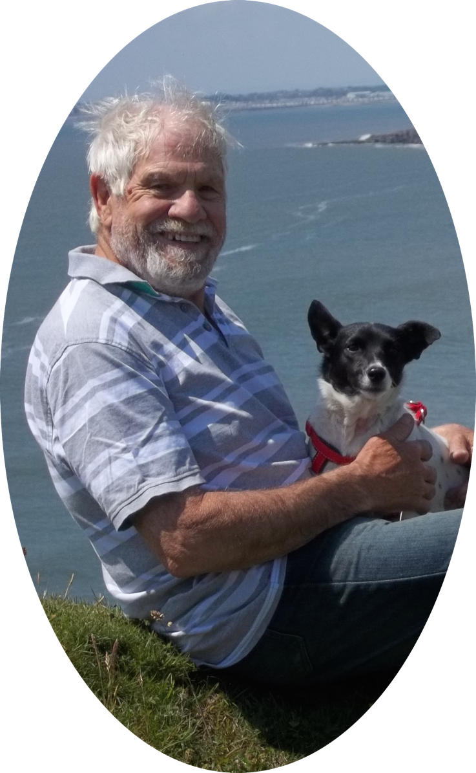
Conducted by
Steve Parry
Humanists UK
Accredited Funeral Celebrant

Larry was born in Llwnypia on the 19th of October 1940, the middle child of Leonard and Eirwen. His father had been in the military but had been invalided out before his marriage. Shortly after Larry's birth the family moved to Llantwit where Leonard worked as a civilian mechanic on the airfield, throughout WWII.
Larry grew up in Llantwit Major with his two sisters, Lorraine and Marianne, They were very close, they doted on him and he was protective of them. They grew up in the years of rationing during and after the war and money was tight, so they went without many things considered necessities now and certainly had no luxuries. Larry remembered these times throughout his life and hated the waste of money or things. He and his sisters were ahead of their times in terms of reusing and recycling.
After the war his father went to work in Aberthaw Power Station, so the family stayed in Llantwit. Larry and his sisters spent much of their time outside and he often spoke about the many summer days they spent on, the then sandy, Llantwit beach with their mother and of long walks with his father, who taught him about the local wildlife and birds and showed him where to find wild strawberries.
He was very bright and won a place at Cowbridge Grammar School where he gained good O level results, although he did not describe his schooldays as happy as he was small for his age and often bullied.
Later, while the family remained in Llantwit his father worked away in a leather factory in Abingdon and lived on a houseboat. Larry took the earliest opportunity he could to leave school and moved to Abingdon to live with his father and take a job at the leather factory. He worked there for about two years before he joined the Merchant Navy as an able seaman until he joined the RAF in 1959 for a three-year stint as a radar technician.
His first posting was to the Shetland Islands which he enjoyed, telling his family later how the locals used to entertain them with ceilidhs. He was then posted to RAF Wartling, a radar station on the south coast. It was a small station where everyone knew everyone else. Also posted there was a young WAAF communications operator, Christine, who was to be the love of his life.
Larry's three-year stint finished, and they were married in July 1963. While Larry left voluntarily, marriage meant that Christine had to leave as there could be no married WAAFs. They moved to London where Larry worked as a draughtsman.
Lorraine was born two months early in January 1964 followed eleven months later by Carolyn in December. Between the girls being born, Larry joined the Navy as an officer pilot trainee and was stationed in Dartmouth for officer training when Carolyn was born.
But Larry had to leave the family in Swindon as there were no family quarters. For his next posting he was able to take the family and they moved to York while Larry underwent pilot training on Tiger Moths.
Officer family quarters weren't offered to officers younger than twenty-five, so they lived off base in rented accommodation in York and again when he started his training as a helicopter pilot in Helston, Cornwall. But as he turned twenty-five during the course they eventually moved into officer quarters. With subsequent moves they had eleven addresses over the next five years before the girls started school properly.
Once Larry was fully qualified he was posted to HMS Albion and over the following years he was involved in the air-lift of British subjects from Nigeria during civil unrest, served in Malaya, and later in the evacuation of Aden where he was a pilot and liaison officer. He later said that one of the scariest things he ever did was being in a British jeep driving through Aden at night while wearing a white Naval Officer's shirt. An easy target.
Their last posting was to Lossiemouth where Larry was an air-sea rescue pilot. This was a high risk and high-pressure job in those days and Larry saw several of his colleagues killed. He realised that his life depended on one bolt in the rotors and that this was not the life for him.
But that is being flippant about the situation. Today, we would hope that he would be identified as suffering from PTSD, but in those days, there was no such recognition and he and Christine were left to manage and a difficult few years began, though looking back Christine realises it was actually a long time until he recovered.
Larry and Christine moved to London and trained as publicans, but this meant that the girls had to go to Christine's mother while they were trained, and it was difficult being separated from the girls. They managed a pub for about six months, but Larry found this very stressful and they soon realised this was not the life for them either and they moved to Cathays in Cardiff.
Larry undertook a three-year teacher training course. But again, with the continuing effects of PTSD he realised the stresses of a teaching profession were not for him. But while training he met three very good friends and he was to remain close to Haydn, Alun and Pete for the rest of his life.
After leaving teacher training he did several temporary jobs before he started to work in the Civil Service within several departments. Over the following years he progressed in work and the girls grew up and the family moved to a nice house in Riverside Terrace in Ely. This was perhaps the beginning of the most stable time in his life. He liked to take the family out and about at week-ends and school holidays. Camping was a family favourite, but days at the beach or out with friends or the wider family, were also very popular.
In 1985, their girls were grown, Carolyn was married, and Hayley had been born when Larry saw an opportunity for a change. He came home from work with a big smile on his face. He had been offered a good job in the Engineering and Science Research Council in Swindon. Christine's parents lived in Swindon and this meant she could live close to them and help them as they got older. So, they moved, and Christine also got a job in the Research Councils.
In 1989 Larry had a heart attack and underwent by-pass surgery. This changed his life in many ways. He retired on ill-health, which gave him the opportunity to enjoy his life and when the surgeon told him that the average life expectancy after such an operation was ten years, Larry decided that he would take that opportunity to make the best he could of the time he had left.
This became more pressing for him when he passed the ten-year mark and since then, for the last twenty years in fact, he has told people that he didn't have much time left and that he was going to make the best he could of it.
Hayley told me that he loved to party, he enjoyed the company of other people, he was a real joker with a good sense of humour, always smiling and enjoyed making others laugh.
The family used to spend a lot of time at their holiday home on a Haven Holiday Resort near Kidwelly and Larry made the most of their social life at the clubhouse on the resort where they had a great deal of fun. One of Hayley's earliest memories is of being embarrassed when Larry got up on stage and sang.
Larry spent a lot of time with Hayley as she grew up and so they have always been very close. So that Carolyn could work, he took on a lot of childcare duties and taught Hayley many things, how to ride a bike, how to swim and on clear nights at Kidwelly, using his telescope he would show her all the constellations and taught her their names.
He enjoyed all the time he spent with his grandchildren. Tavis and Tegan moved to Australia with Carolyn and their father, Mike, when they were young, so he didn't see them as much as he would have liked, but he was always interested in everything they did and incredibly proud of all their achievements.
He walked a lot to improve his health and enjoyed long walks accompanied by his beloved dogs, Jenny and then Maggie. While he enjoyed walking around Swindon and the countryside he always missed the sea and often went for long walks along the coast.
After his childhood in Llantwit, his time at the coast on holiday and his service in the both navies, he was always happiest by the sea and had owned a boat at one point. So, after Christine retired and her mother died the draw of the sea called Larry and Christine back and in 2008 they moved to Barry.
They bought a house within a hundred yards of the Welsh Coastal footpath where he could go on long walks with Maggie and only a couple of hundred yards from the National Coastwatch Institute's station where he volunteered for a while.
You can tell from the jobs that Larry held during his lifetime that he was a very intelligent man, but in recent years it had become apparent that he was losing his memory and was diagnosed with Vascular Dementia. He had always been very proud of his intellect and was frustrated with his new condition.
His sudden death came as a great shock to Christine and the rest of the family as there was no warning. He was fit the day before, cooked tea and went to bed as normal, dying peacefully in his sleep.
This has given his family a great deal of comfort, as does knowing that he felt he had had twenty years more than was expected and given the choice may well have preferred to go before his beloved dog Maggie or his dementia became a lot worse.

