‘A celebration of the life of’

Olive Smith

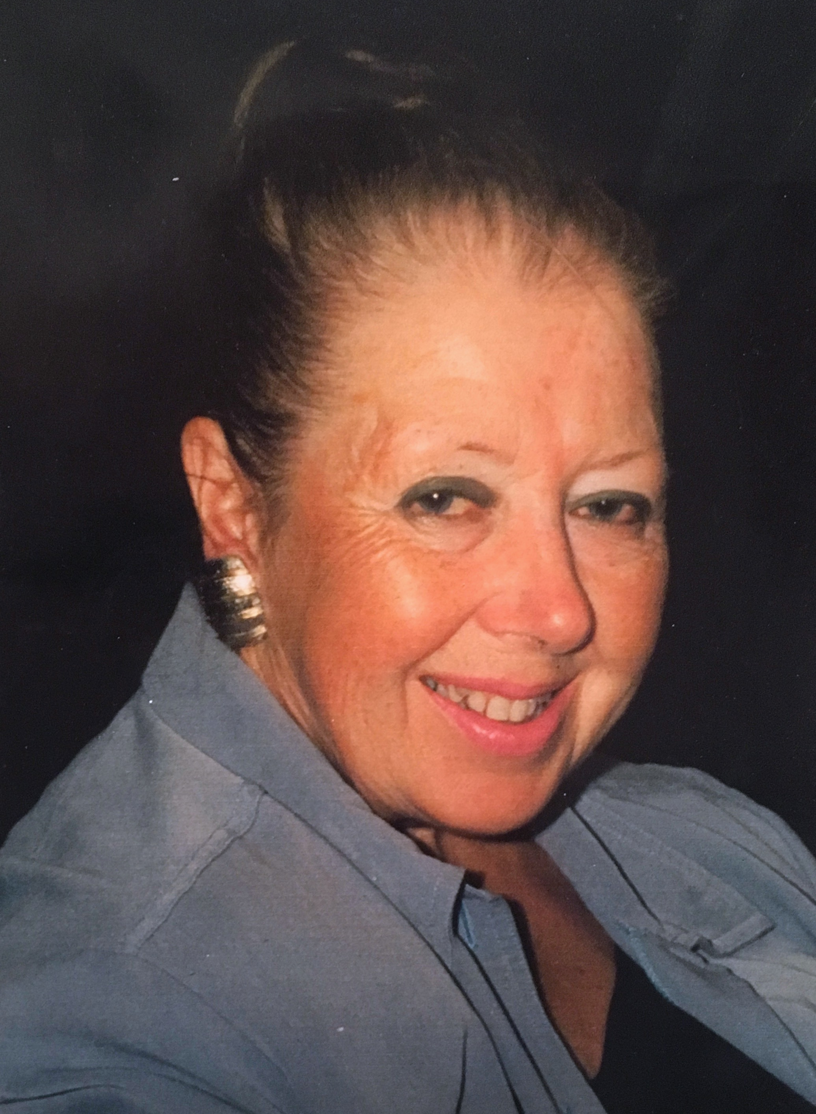
3rd July 1938 - 19th January 2017

Seven Hills Crematorium, Ipswich

Friday 3rd March 2017
3:00pm

Olive Smith
3rd July 1938 - 19th January 2017

Eulogy for Mum by Gillian:

“One the 3rd of July 1938 The Mallard Locomotive achieved a new UK record for Steam Trains travelling at a little over 125 mph. There was however, another far more important event that day: the birth of my mother Olive, daughter to the wonderful Fredrick Bernard and Olive Pollard, and sister to the handsome and jovial Kenneth.

Born on a Sunday, my mum was the exactly as the verse says: “But, the child who was born on the Sabbath Day, is bonny, blithe, good and gay “
My mum had numerous qualities, her greatest one being that she put others first; always above her own needs or wants. She was kind, generous, a good listener, extremely funny, intelligent, patient, and a diplomat. She really was a beautiful person inside and out.

She was very positive influence on everyone she knew, and people seemed to just like being around her. It takes a real strength of character to deal with all she had to, whilst always remaining cheery and bright. The nurses and carers often told me she was the easiest person they had looked after, because she was so polite and good humoured.

My Father said that from the moment her met her, he knew she was the woman he wanted to marry, and after only 3 months, he proposed. They spent over 43 years of married life together, even sharing the same birthday. In sickness and in health, he ensured she was cared for. He fought tirelessly for Ollie, (as he called her) to ensure she spent the remaining years of her life in the comfort of her own home and not a care centre. He was her constant and true companion.

My mum loved life and all it had to offer including, music, dancing, painting, cooking, baking, friendships and family. She also enjoyed travelling, living in Singapore in her twenties, Cameroon in her forties, and visiting France, Spain, Italy and Portugal for holidays. That said, she was easily bored, and consequently was always doing something industrious. Her brother Ken said to my dad (in jest) on their Wedding Day, “I hope you know, she takes a lot of amusing”. But, my dad enjoyed their adventures, the travels, the days out, and the relentless leg pulling. He was a thoroughly willing participant in their journey through life together.

Olive delighted in being a mother to my brother Simon “her Beautiful Boy” and to me, Gillian “her Little Treasure”. My brother inherited my mum’s sense of humour and ability to tell a good tale; he was constantly making her laugh with his escapades (much to her delight). I meanwhile inherited her love of painting and drawing, a skill of hers, which I greatly envied and admired. In later years she became the nana to three grandchildren, Olivia Mary, Nicholas Fredrick, and Sienna Poppy. She was so proud of them, and of all of their achievements. Just having them all in her life spurred her on.

I don’t have any regrets regarding my mum, I told her all the time how much I loved her and how much I liked spending time with her. We laughed endlessly, put the world to rights, and enjoyed each other’s company. My brother, though separated by thousands of miles, was never far from her thoughts. They had long, happy, frequent telephone calls, and spent some real quality time together, when he and the family visited around Christmas time. I know how very much this meant to her.

Sadly as with everything in life, all good things must come to an end. The joyful memory of her however, will never end.
Mum: “You are Stardust, and to Stardust you will return”.

Eulogy for Mum by Simon: Read by Suzanne

“My mum Olive, was the kindest person I have ever known. She had an amazing sense of humour and an incredible strength of character that I am sure especially for the last few years of her life was clearly demonstrated when most of us would have simply given up.

When I was born, it was a difficult time for my mother and she had some difficult decisions to make. I never realised throughout my early childhood and further, the sacrifices she had to make to make my life what it is today. She was love and kindness personified, and loved her family and her grandchildren equally and without question. Even though for the last 13 years I have lived on the other side of the world, we kept in close touch and I simply don’t know who I am going to talk to now about the Tennis, which she loved watching.

One of the last conversions we had made me laugh, mum was concerned about how people many lived in the UK now, and was concerned that the UK might actually sink one day if we don’t watch it.

I am grateful that I had the opportunity to have quality time with my mother recently, and it goes without question I will miss her every day, but I am also glad that she no longer has to endure the debilitating illness, and I will be eternally grateful to my father for everything he did for my mum especially in the latter years when mum became completely housebound.

RIP Olive Smith a son couldn’t have wished for a better mother.”
Eulogy for Ollie by Howard:

Ollie, my darling wife.

“In the summer of 1972, after three weeks of holiday in the sun, following my final year at university, I returned to Harrogate, that gem of the north, to wait for a transfer to the BT Research Laboratories in Ipswich. Within a couple of weeks, when I was just 29, Ollie appeared, like an angel, in my life at a nightclub with her friend Dotty, whom I sat beside. It was the next best thing I could do. After a dance with Dotty, I sat down, and on a mad impulse, said to Ollie

"And I'm having a dance with you, too, before I go home!"

She smiled, and I knew, I just knew, in that instant, that this was the girl I wanted to spend the rest of my life with. I got the dance, and I got the girl. I think I saw her every day for the next three months. My mother, bless her, must have thought I'd abandoned her! Ollie showed me more of North Yorkshire than I ever knew existed, and it was a time of absolute joy.

She was such a gentle, interesting person, who loved to talk about family, and her close friends. I asked her to marry me near the end of October, just before I departed for Suffolk. I travelled back and forth, madly, between Ipswich and Knaresborough, every weekend until we were married in March 1973. That first smile, which I so cherished, was to become an integral part of my life. Whenever we passed each other at home, or when meeting, it was there, always, and my heart soared every time I saw it.

Ollie loved to travel, and we did, often, usually at her instigation. A home was somewhere to put your head down, she said. Even in later years, when her health problems started, she still wanted to be out and about. She loved to take our daughter, Gillian, to school in Framlingham, quite a few miles away, and then go to the seaside at Aldeburgh and watch and listen to the sea for an hour or so.
She loved the outdoors, and, as an artist, she painted many pictures when she could. She was also an excellent cook, but she always made us laugh when it came to doing over-complicated recipes…"Life's too short to stuff a mushroom"

She’d say! She didn't like wasting her time.

Ollie was always there for us when she was able; she adored her children, Simon and Gillian, and later, of course, the grandchildren, Olivia, Nicholas, and Sienna, who, I am happy to say, are here today, and will be remembering her with so much affection.

She was, without doubt, the truly great love of my life, and I will miss her all the more for it. She will remain in our hearts forever.”
Olive Smith
03/07/1938 – 19/01/2017

Conducted by
Billa Eastoe
Humanists UK
Accredited Funeral Celebrant

Tribute

Olive was born on the 3 July 1938 in Dragon Parade, Harrogate, North Yorkshire, the second child of Fred and Olive Pollard. She had an elder brother, Kenneth, who, she said, teased her unmercifully as a child, but as they grew older, he became very protective of her, and they remained close all their lives.

Shortly after the Second World War started, the house in which she was born was requisitioned to take in more people, so her parents moved to a smaller house on East Parade, so that they would have it to themselves.

She attended Grove Road School, but was not much enamoured by her schooldays, and was pleased when she could start work. However, when she was twenty she met John who became her first husband, and was immediately whisked away to Singapore for three years, as he was in the RAF. She had a marvellous time there, and became lifelong friends to many other RAF folks – Maureen and Ian, Bob and Isma, Derek and Carol, Ian and Jackie, and quite a few others.

On her return she lived near the many RAF bases in and around Wiltshire, and remembered fondly her work as a typist at the MOD Shrivenham College of Science and Technology. She always said that John was the life and soul of any party, of which there were many, but after twelve years, they parted company. Soon after, she went back to Harrogate, and worked as a typist at a Post Office Telecomms training school for technicians.

It was while she was in Harrogate that she met Howard, in August 1972, who also worked for BT, as it is now. In November, he asked her to marry, and so they were in March 1973… Coincidentally, it turned out that Howard worked on East Parade, where Olive had lived as a child, next door to what was Howard’s office! There is even a photograph of her sitting on the wall in front of what was to become his office. A small world! And they even shared the same birthday, which made it easy when it came to remembering them!

With two children, Simon and Gillian, plus Pepe, the Chihuahua, the family moved to Ipswich, where Howard then worked as a silicon chip designer at BT’s labs, and where they spent most of their married life together. Olive still continued to work as a typist when the children were older, again for BT, and later for the Suffolk Constabulary. However, in 1982, the family moved to Cameroon, West Africa, for two and a half years, quite an experience!

In the years that followed, grandchildren appeared; to Simon and his wife, Suzanne, Olivia Mary was born in 2000, her brother Nicholas, in 2002, and to Gillian and Rob, Sienna Poppy was born in 2010. They have been, and remained, the joy of Olive’s life, especially in her latter years.

It was in the mid-eighties that Olive became aware of health problems and was diagnosed as having a rare condition known as syringomyelia, and over the following years she slowly lost mobility. In spite of this, she lived life to the full, going on holidays to France, Spain, Italy, and Belgium. It was on her last holiday in Spain, 2004, that she fell and broke her hip. This was to be life-changing, and she never walked again. However, with the help of her electric joystick ‘buggies’ life carried on, and East Anglia became better and better known as the years went by.

However, in 2010, syringomyelia struck its final blow – she was unable to breath on her own, and had to have a tracheostomy at Papworth, and have a permanently connected ventilator. She became house-bound. With the help of live-in nurses, a daily carer, and Howard’s help, she continued to enjoy her family’s and friend’s regular visits. Thankfully, she remained, almost to the end, as bright as a button, and interested in all that went on around her. Sadly, after almost forty-four years of marriage to Howard, she quietly passed away on the 19th January, 2017. She is greatly missed by all who knew her.

Ceremony Conducted by Billa Eastoe
Accredited Humanists UK Funeral Celebrant

Tel: 01473 413617
Mob: 07812 209168
Email: billa.eastoe@humanistceremonies.org.uk

http://humanist.org.uk/billaeastoe

https://humanism.org.uk

Humanists UK, 39 Moreland Street, London EC1V 8BB
Tel: 020 7324 3060 | Fax: 020 7324 306

