Ceremonies to say farewell to

RALPH TREVOR MARTIN
(28th July 1947 – 23.10.2017)
And to celebrate his life

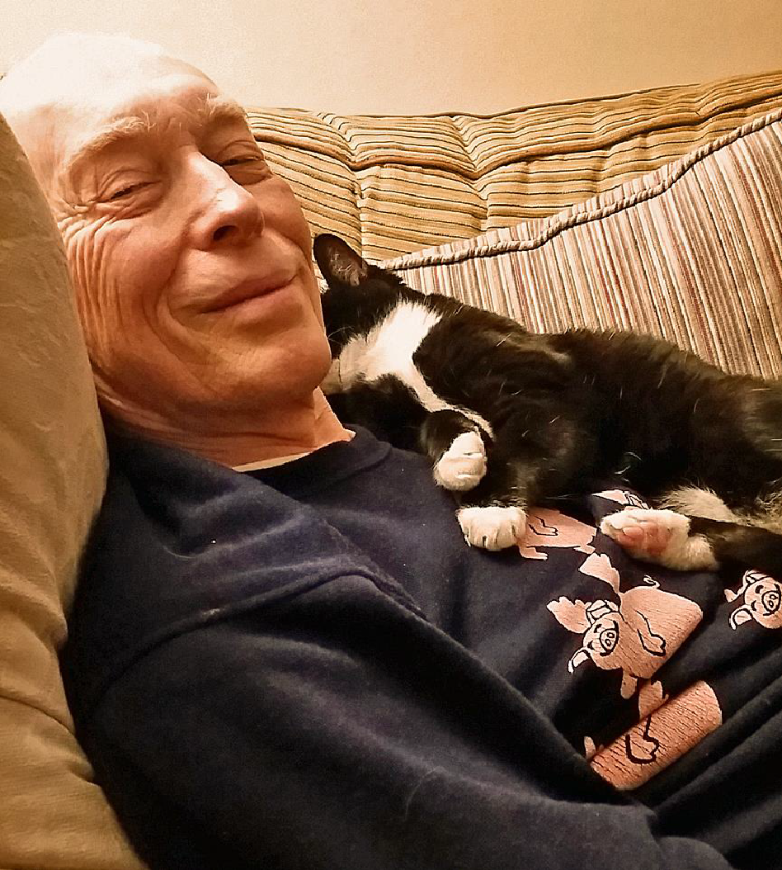

On 23rd November 2017
at Westfield Cemetery, followed by the Red Cow Public House

Celebrant: Mary Porter of Humanists UK

Ralph was born in July 1947 in St Albans, the son of Blanche Kirkman and Reginald Martin. He had just one sister, Josie, who died in May 2015 – and who was buried, as were their parents, here in Harpenden, in the cemetery where we just said farewell to him.
Ralph grew up in St Albans and Wheathampstead and went to Aylesford House prep school and St Columba’s College. His father was a non-practising catholic and Ralph a non-believer in all the years Irene knew him. His father worked for London & Midland Railways and married his mother just before he was called up for the Second World War. On being demobbed his father returned to his old job as auditor with what was later to become British Rail. Ralph loved trains all his life - as a boy he had experienced first class train travel all over Europe – one of the perks of his father’s job which allowed the family to travel free of charge as far as Yugoslavia. Ralph’s mother was an excellent and creative gardener and transferred a love for growing things to her son.
As a young man Ralph was very practical. He did woodwork and loved tinkering with cars; He once had a motor bike is his bedroom where he could take it apart. We will hear more about this from his friend Gordon. His parents encouraged him into following an academic path, which he always said he regretted. He did try training to be a teacher so that he could teach woodwork. He stood it for a year - but it turned out that he was too nice to be comfortable dealing with the battles he faced in the workshop to keep the pupils safe.
So his hobbies remained his hobbies and, as Irene puts it, he had a rather chequered early career. He went from being a concrete tester, to running an electrical shop, to being a technical adviser for GKN, the engineering company where he got involved in various building projects but he wasn’t there for very long. Then he settled down as a technical manager for an electrical company where he stayed for over 20 years until he was made redundant at the age of 54. Rather than this being a disaster robbing him of everything that defined him (as it so often feels to those made redundant at around that age) this was his opportunity for his practicality and creativity to become his core business.
Before moving on to this turn-around in his life, I will return to the essential part of his story: meeting Irene – a young woman of Dutch parentage, who had been brought up in Belgium. She had come here to improve her English, intending only to stay for a year. But then Josie, Ralph’s sister introduced them at a party. This was when he was about 26. Irene was immediately struck by - as she describes him - this gorgeous Englishman - so different to all the Dutch and Belgian men she had known. She was sure within minutes that he was the one for her, but it took, as she puts it, a while for him to be persuaded. But persuaded he was and they went for their first date in his beat-up mini to the Tin Pot Inn in Gustard Wood. This led to them getting married some 42 years ago.
It was a very happy marriage. Irene introduced Ralph to some of her more intellectual pursuits. He would go with her to concerts of chamber music at the Wigmore Hall and to the opera and he grew to appreciate the lieder that Irene loved. He relied on her to recommend books to read – such as Philip Pullman’s works, good detective novels or the Mapp and Lucia novels of E F Benson. Ralph and Irene enjoyed many happy holidays, and also enjoyed city breaks with his sister Josie and her husband, Chris, to places like Cologne, Vienna, Lille, Paris and Antwerp.
Ralph and Irene always had cats. He loved them and they loved him. In fact Irene’s “mad cat lady” twitter group, as they call themselves, called him a “cat magnet”. Anyway it was one of their cats that led to the transformation in Ralph’s working life. It started when Gemma (the cat) took their three piece suite apart with her claws. Having found that it would be a year before a professional upholsterer could redo it, Ralph - determined man as he was - decided that he would do it. So he took evening classes in upholstery and found he really enjoyed it.
With Irene’s blessing this inspired him, following his redundancy, to take a two year course at the London College of Furniture, which led to his very successful upholstery business. In fact you can see some of his work in the seating here. He struck lucky early on by making up a couple of visiting cards which he dropped into Chelford Fabrics in the hope they might have customers who needed upholstery done. Within two days they called him and asked him for a stack of cards, as indeed they regularly were asked if they knew someone. That helped him a great deal in setting out, as did the help and support he got from other professionals in the furniture business.
What made his business successful was not just his undoubted craftsmanship – it was his personality. As we can tell from the many, many cards that people have sent Irene, he was lovely with everyone, customers as well as friends. In all aspects of his life he was cheerful, kind, gentle, warm and welcoming. If he could help he would. With the allotment society he was always supportive, always ready to give advice, he would be fixing things and helping people out. In his business he loved passing on his skills and working with students. He found out by chance about the EU’s Leonardo programme, which funded vocational education and training. So he and Irene took in a number of foreign students, with some of them living in their home with them and they became good friends to many. He was much valued as a teacher. One of the many, many cards that Irene has received said, 'he was an inspiration and help to me and my students'.
So he had a wonderful working life in recent years – one where he could bring his creative skills and his very personal qualities to his work. And he further developed his artistic side: he went on metalwork and stone carving courses at West Dean College. As we soon will hear from Richard Sweetland he made beautiful ornamental metal work – including the stunning creation in their front garden. He also made the spiral staircase to gain entry to the loft – which he insisted that he could and would make, irrespective of whether there was planning permission. He certainly had a determined – some might say - stubborn streak.
Ralph was diagnosed with advanced prostate cancer in 2015, with a prognosis of three to four years. He took this on the chin and became even more creative and produced even more.
Rather than withdraw from life he lived his life with even more enthusiasm, keeping fit, cycling and going to his allotment. Although he didn’t talk about his death much, at the same time he was making sure that Irene could live her life well, beyond his life-time. He wanted to ensure she could manage and he wanted her to be happy. So he fully supported her starting her Open University Course, knowing full well that this would be especially important for her when she was adapting to life on her own.
He kept going so well like this until his last six weeks. Even so he was still his stubborn, determined self. Irene took him with her to the allotment a few days before he died, assuming he would be too weak to get out of the car. Not Ralph! She turned round to find him behind her getting along with a walking stick on one side and a garden fork on the other. And he stayed stubborn – refusing help even when it could have made life easier. So he stayed himself: he wasn’t diminished by his failing health.
But in the end Ralph couldn’t cheat death – and having said all that they needed to say to each other, Ralph died in Irene’s arms.
Ralph may be physically gone but, quoting from the many cards that Irene received this good, gentle, kind, sweet, generous, creative, talented man leaves so many, many happy memories and will never ever be forgotten.
Now we will hear tributes to Ralph.
Irene Boogerman
If love alone had been able to keep Ralph alive, he’d still be with us today. Not just my love, but the love and affection in which so many of you held him. In my own grief at his loss I’ve become very aware of how so many of you are missing him. In a moment you’ll hear a poem by Richard Gibb, one of his allotment neighbours, that expresses this.
Ralph was a lovely man. As W H Auden put it, “He was my North, my South, my East and West”. I often said he was the nicest man I knew and I meant that. He had a sweet and kind nature and he did indeed like to help people.
As Mary mentioned earlier, he could also be very obstinate, which was something of a family trait. At its best that obstinacy turned to persistence, whereby he would quietly work away to achieve his goal, which might be a difficult piece of wood- or metalwork or endless experiments with sour dough bread starter cultures cluttering up the fridge.. Wherever I look in the house I see evidence of his skill with his hands. That provides a small measure of consolation at his loss.
We did spend a lot more time together after his diagnosis. That time went by all too quickly and although it was expected, his end came upon us by surprise, with a speed we did not anticipate. That did mean he did not have to suffer as long as he might have done, which is another small consolation.
I was lucky to have him in my life for more than 40 years. He’s left a very big Ralph-spaced hole and I am so glad you’re here to share some of the stories about his existence. Thank you.
~~~~~~~~~~~~
Elly McDade
My lovely Uncle Ralph is easy to talk about. I knew him my whole life and spent my life sure of his kindness and calmness. I also spent my life sure as anything that at any gathering, if you looked away for a moment he would be asleep, on a chair, on a bench, nodding off, and one memorable occasion under a table when Andy and I didn’t have much furniture in our first flat.
When he was awake he was busy, making something with his hands, growing things, baking bread –creating and nurturing in his very understated, capable way. My in-laws always marvel at Ralph’s capacity for eating on the occasions that they have met him, and that his home grown sprouts were a thing of abundant wonder at a particular Christmas gathering..maybe a little too abundant!
My parents knew Ralph from when he was a boy, he lived next door to their best friends with his family – and it probably speaks volumes about him that my Mum was happy for her little sister to go out with this bright, kind boy, and subsequently marry him.
Irene and Ralph only ever had eyes for each other, through thick and thin and Mother in Law not withstanding they built a life together and around each other. They have a great many dear friends who they love to spend time with enjoying the argy bargy of the allotment society and lively gatherings. These true friends have been of great support particularly in the last couple of years, Eve and Eric, Lin and Colin, Chris and Angela, Mary and Carl to name a few – I’m know there are many more, I’m sorry for not naming you all, but I know that it meant more to Irene and Ralph than words can say.
Ralph and Irene raised 4 cats Roxy, Lilly, Gemma and Rani. He loved to spend time with his lovely sister Josie, brother in law Chris, and nephew Ashley, niece Marissa and now his great niece: Lily.
I lived with Irene and Ralph for a year when I was 17. Living with a fully-fledged teenager probably tested that good nature, but he was always full of tact and grace, a ready smile and interested enthusiasm for whatever nonsense I was spouting that week. Irene’s brother Rudi also lived with them from time to time, joining in with the artistic endeavours and cat loving, I think he fitted in well. Their generous hosting also extended to Ludi, Ralph’s unofficially adopted daughter – they love to go to France to spend time with her, her husband and little son, and also to various other apprentices in Ralph’s upholstery business.
As he was kind to me, he was also very lovely with my children, patiently helping them to harvest peas or listening sincerely, never dismissive. I asked my husband, Andy, and my children what they think of most when they think of him and they all said his warm, genuine smile. Also his oinking pig jumper and they said that he was a man happy in his work, always finding something to do that he loved – which sounds to me like a life well lived.
Gordon Chichester –Miles
I am not surprised to see so many of you here today to give Ralph the send-off he so richly deserves, although I would rather we were not here at all on this occasion.
However we are here and I should like to give you all a brief outline of the Ralph I knew and will miss.
I have known Ralph for nearly 60 years like my brothers and my mother who are here today, albeit we may not have seen each other for a few years sometimes, but we always seemed to meet up again and begin where we had left off last time. We first met when he arrived at our farm in Wheathampstead. His mother and mine had agreed that he should walk to the farm and play with my brothers and me and he duly knocked on the back door of the farm house. We never looked back, not like we do now, they were simple carefree and warm sunny days we enjoyed them all. We built “Camps” in the bales of hay and straw in the hay barn and the fields, and then heard the language from the working men as they fell down into them. As we grew older we did more work on the farm and Ralph was carting and stacking bales in the barn with all of us on the farm.
Ralph’s milestones were often to be seen at the farm, his “Huffy” bike with big fat tyres and big frame, not a normal bike but one that was unique to Ralph like many of his creations that were to come. His Sunbeam S8 Motorbike that he had fitted with “Ape Hanger” handlebars and driven by a prop-shaft not a chain, something a bit special, just like Ralph, and he boasted he got it up to 100MPH on the new Marford Road. Don’t think he told his Mum that or his Dad. When he got me on the back he scarred me witless, I said witless. He would drop the engine out just to clean it, He loved that bike. He graduated to a “Bond” 3 wheeler car because I think you could drive one on the road then with a Motorbike licence and not need to pass a car test, there was also a Messerschmitt 3 wheeler.
We often used to go to his house in Wheathampstead and had great fun in the old Air Raid shelter in his garden, what a dark, dank place that was. Ralph’s practicality would never be suppressed. He went on to build his own, one man Hovercraft using, I think, a Villiers motorcycle engine. He made it out of plywood completely from scratch and it did run but I don’t remember the final outcome. It was not a commercial success unlike his foray into making small, large and very large wine-racks that he sold around the country without the aid of the internet but by using good old fashioned advertising. He had an electrical shop in Southdown, Harpenden that he ran with his friend Dave Stewart. I bought my first calculator there. Here I still have it.
Ralph was always busy doing something and in the midst of his busy life he met and married Irene, I was there as well. He went on to work for an electrical company I think on various different sites for some years before retraining as an upholsterer. He has done some of my grand old chairs twice or maybe more now, and even the Parker Knoll I inherited from my grandfather is still going strong thanks to Ralph’s dedicated and skilful handy work, What will happen to it now?
In 1990 I decided to build a new house in Aley Green and spoke to Ralph about the electrical installation, he knew all about the latest rules and regulations and how it should be done. Consequently he did the whole of the installation for me and did it perfectly not a single hiccup I can remember.
We both went to the same school, St. Columba’s College in St. Albans but he left not long after I got started, he was still 2 years older than me.
There are many things that will come to mind in the future, as time goes, by about the history and times that you and I have shared with Ralph through his life. All of them good times and worth remembering.
Words to describe my good friend Ralph, friendly, amiable, practical, helpful, loyal, dependable and steadfast, and many, many more. Memories we all have of a kind and caring man. They really did break the mould when they made Ralph Martin. Rest in Peace Good Friend.

Richard Sweetland
Firstly I would like to thank Ralph's family for the privilege of speaking at this very sad occasion.
I knew Ralph as a craftsman and friend. When Ralph was working he would call to arrange a time to bring round a broken part of some ancient chair which he was refurbishing. We would chat about metalwork and the latest project he was working on. On a few occasions we worked together in assembling Ralph's latest creation.
Many of us in life never discover our gifts or talents. Ralph was a guy who did. You only have to pass by Ralph's house in Cowper Rd to see the ornate railings manufactured by Him. With regard not only to the railings but to all of Ralph's metal art work a lot of skill is required in its initial design, planning, methods of manufacture and the actual work in manufacture.
I was aware Ralph was very poorly, however I took inspiration from Ralph in the way he continued in his determination to continue 'forging' onwards despite his failing health. I truly admired him for that and I believe we can all learn from that aspect of Ralph's life in never giving up no matter what life may throw at us.
Finally I would like to thank you Ralph for your friendship. It was a joy to help you out on occasions.
Needless to say we are all going to miss you greatly as we say goodbye. The world has lost a truly remarkable man.

