A CELEBRATION OF THE LIFE OF

VERONICA ANGELA TOWLER
12th June 1941 – 2nd February 2018

held at
Banbury Crematorium
on Monday 26th February 2018

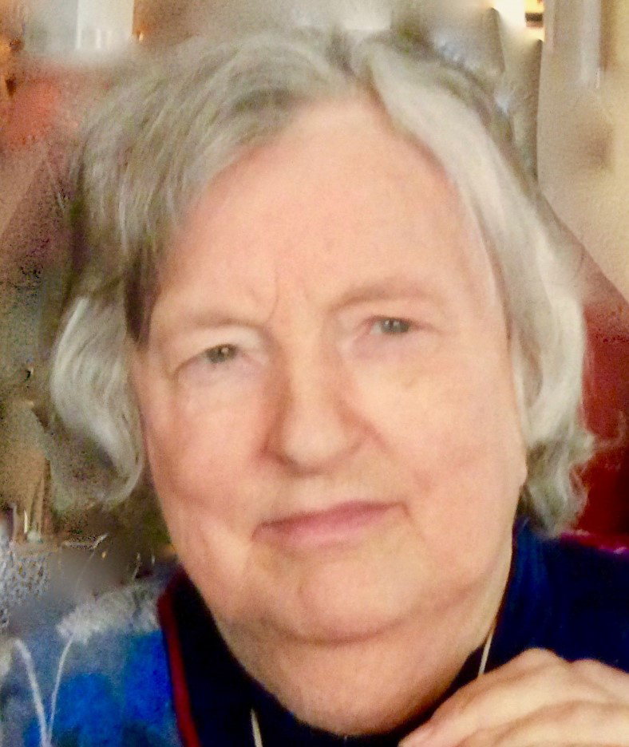

Humanist Celebrant
Ian Willox
01865 589 663
ian.willox@humanistceremonies.org.uk

Humanists UK
39 Moreland Street, London, EC1V 8BB
020 7324 3060
www.humanism.org.uk

Funeral Director
A.L.Sole & Son
Chipping Norton

ENTRANCE
Lark Ascending – Vaughan Williams

OPENING WORDS
Good afternoon everyone. We’re here to celebrate the life of Veronica Angela Towler who died at The Old Prebendal House on 2nd February aged 76.

INTRODUCTION
I should introduce myself. My name is Ian Willox. I’m a celebrant for Humanists UK. Veronica’s family have asked for a non-religious funeral. That doesn’t mean anti-religious. This is a ceremony for everyone – including those with a religious faith.

THOUGHTS ON LIFE AND DEATH
With or without religion, one of the important things a funeral does is to remember – so that Veronica lives on in our memories at least.

So let’s remember…

TRIBUTE
…starting with her cousin Judith:

JUDITH MIDDLETON:
Thank you all for coming on this very cold day. I’d like to start by saying that there are others with us in spirit. And I should like to name them. Deborah my sister in Shipton under Wychwood, although often forgetting that Binkie is dead still misses her when she remembers, Christine a friend of 35 years who met my cousin at our wedding and who has supported me so much over the years is presently in Portsmouth Cathedral; Rip in Amman, Jordan, my oldest friend and like a brother who in the last 7/8 years was a friend to Binkie as part of our family; John and Colette, cousins in Ottawa, Diana (aka Sr Gabrielle Mary) and the sisters of precious blood in their Toronto convent, Rosemary and Hal in Santa Monica, California, and Rona Geffen (Mike’s sister) in Johannesburg who invited my cousin to her daughter’s wedding when we were in South Africa in 2000. They are all thinking of her right now.
Veronica Angela Towler was my first cousin. While most of you here today know her as Veronica, for me and her family she was and always will be Binkie, a much loved cousin.
Binkie’s parents William and Vera were born either side of the turn of the 20th century, so their salad days would have been in the 20s when perhaps Binkie was a more popular name than it is today. It may also have been easier for a little child to say Binkie than Veronica
Binkie was the oldest of 6 cousins - Binkie, me and Deborah, and John, Diana and Rosemary in North America - all children of the “Coles girls” our mothers’ maiden name.
In the first 4 years of her life she was the apple of not only her parents’ eye but of the whole family’s. Then I came along, and she recalled she did not know what all the fuss was about when she first saw me when I was born. I spent many months of my early life staying with Binkie and her parents as my sister Deborah was very unwell at birth and later my mother was ill when I was about 5, so in one sense Binkie became my big sister, and certainly as a child, parties were not the same if she was not there.
Essentially brought up by Edwardian parents, she lived in Beckenham and went to a Convent school (although not a Catholic herself) and then the grammar school where she did very well. She sadly lost her father suddenly at 15 years old and I think the consequences of this marked her life, as from that age she felt responsible for her mother (whom she often described as a widow who needed her support) although in fact her mother was a competent and successful business woman well into her 70s.
Binkie took a degree in general estate management at London University, which in the early 60s was unusual and quite brave and she was only one of two women in a year of 50, and then worked as a Surveyor for a short time.
Soon after this, she went to Exeter University to study social work, and then worked as a social worker for a year or so in Havant. I think those of you who knew her well may realise that this was really not the kind of career which suited her best and it seemingly triggered a series of breakdowns and depression, the latter, sadly, recurring throughout her life.
She eventually returned to be a chartered surveyor, and if I remember, worked in Leicestershire, Manchester, Newport, Redditch and finally in Warwick. I know when she finally retired she was given a very fine retirement party, which surprised her, so obviously she was well liked and much respected at work.
Binkie’s relationship with her family has always seemed ambivalent, particularly with me, as I must have seemed to be the second child intruding into her family at a critical time when she went off to school. However, she has always been very fond and supportive of Deborah my sister who has learning difficulties, helping me find a care home for her in the past, and regularly taking her out and occasionally on holiday while she could do so. And for that kindness to Deb I am truly grateful to Binkie. She also was close to my parents and helped me sell their house when they died.
You will see as cousins we were all close. I shall leave John’s comments until the end of this. Although Diana (now Sr Gabrielle Mary) in Toronto and Rosemary in Santa Monica had not seen her for many, many years, during the last few months of her life they have been emailing me for news and wishing her well.

But for all this, I think essentially Binkie was a better friend than a family member. After all we choose our friends and/or are chosen by them, while with family you are just part of it whether you like it or not. And Binkie greatly valued her friends, none more so than Jean: they holidayed together and Jean faithfully visited her regularly over the many years of her illness to the end of her life.
Binkie was a tireless advocate for conservation, taking part in litter picks and working parties along the Oxford Banbury canal, and became for a time the local Chair of the Campaign for the Protection of Rural England, and was interested in local wild life trusts. Some of you will know her as a fellow walker - particularly along the Pennine Way, and at the end of her life she always enjoyed it when Jean or I took her for a drive to check on the progress of the dry stone wall around Soho House not far from here. We chose the Lark Ascending as a reminder of her love of the country.
Over the last 8-10 years she gradually suffered more and more from the effects of her poorly controlled diabetes, gradually losing her mobility and her sight, and in October last year having her right leg amputated, which was no doubt disastrous for her. Binkie was fiercely independent and hated not being in total control of her life in all ways - perhaps not always to her advantage. She desperately wanted to stay at home, and everyone worked hard to try to ensure that this could happen until the burden of care became too much for home carers and she would have put her life at risk. I know she did not want to go to the Old Prebendal House, but better that than being left in a corner of the John Radcliffe where they had done everything for her medically but could not give her the end of life care that she came to need. She died very peacefully and very cared for in the end.
Her interest in reading was about facts or reality - novels, fiction, theatre and music were not things that really interested her. It meant that the Talking Books Service was challenged as she gradually lost her sight, as so few of the talking books focused on subjects she was interested in. Hence, towards the end of her life Radio 4 was her mainstay, as a companion and a window on the world. This did mean she was up-to- date with what was going on even if eventually confined to a chair in her house for most of the time.
Binkie’s death seems to us as a family, the end of an era - or perhaps the beginning of a new one - after all it is us now not them, the older generation, who face mortality. It reminds us of the importance to her (and to us) of family and friends, and how we should value those we still have while remembering those we have loved and now lost.
I shall now read a letter sent by John.

A letter not sent.

Dear Binkie,

I have been meaning to write for some time but the bustle of life kept getting in the way and diverted good intentions. I know you have gone through a remarkably difficult time with health related issues seemingly starting from the time you retired. Equally, I know you have struggled to maintain your independence despite diminished eyesight and mobility problems which I understand and respect. However, I do not want to dwell on your health nor, I suspect, do you. I am writing today so that you might know that you have been an important part of my/our life in Canada and England. The point I want to make is that we cousins are more like siblings and together we have forged a very special bond. We are Family. We choose to remain close, to be a part of each other’s lives, to make the effort of visiting and sharing.

Just to make my point, I can, with very little difficulty, conjure up happy vignettes of time with you, playing together at Chase House in the 1950’s (you who were older, presumably wiser and undeniably taller), learning to scrape/plaster/paint at the farm in the 1970’s, thoughts of various trips to Canada including long bicycle rides when you stayed with us, countless debates on politics with its parry and thrust often with no firm conclusion, memories of day trips you used to take with Mother and those trips further afield such as Toronto, Maine always with an eye for a coffee and donut outlet both mid-morning and afternoon, souvenirs of more recent pub lunches together over a large beer in all manner of small Oxon villages often located because your sense of direction and orientation had failed you (who can forget Whaddon Hall when you and Colette arrived an hour late following unplanned meanderings in rural Buckinghamshire), finally, vivid recollections of your ability to strike up a conversation at the bus stop, in a store, on the street with a local inhabitant all quite naturally, with endearing ease.

I am trying with these few examples to show you how over a lifetime your willingness to try different things, to show good humour, to be approachable and without pretension bind us. These memories, and many others, confirm we belong together, they make us smile and give us the certain knowledge that we are Family with shared roots, common values and engaging history.

I hope this brief letter finds you at peace and serene.

Until we meet again,

John

Judith mentioned Binkie’s friend Jean Nicholson. Here’s Jean herself with her memories:

JEAN NICHOLSON:

We’re going to pause for a hymn. You’ll find the words in your order of service. The Lord’s My Shepherd, I’ll Not Want:

The Lord’s My Shepherd, I’ll Not Want

Judith’s husband Michael is going to bring the tributes to an end with a reading:

MICHAEL BERGER:
“My scheme was not working well. That improvident flight from the rooms and meals and all that went with them at my tutor’s had reduced my funds to a pound a week and the way things were shaping, it looked as though opulence from writing might be delayed for a time.

I managed somehow, but gloom and perplexity descended with the start of winter. Fitful streaks of promise and scrapes and upheavals had marked my progress so far; they still continued; but now I seemed to be floating towards disintegration in a tangle of submerged and ill-marked reefs. The outlook grew steadily darker and more overcast.

About lamp lighting time at the end of a wet November day, I was peering morosely at the dog- eared pages on my writing table ..when, ..inspiration came.

A plan unfolded with the speed and the completeness of a Japanese paper flower in a tumbler. To change scenery; abandon London and England and set out across Europe like a tramp—or, as I characteristically phrased it to myself, like a pilgrim or a palmer, an errant scholar, a broken knight or the hero of The Cloister and the Hearth! All of a sudden, this was not merely the obvious, but the only thing to do. I would travel on foot; sleep in hayricks in summer, shelter in barns when it was raining or snowing and only consort with peasants and tramps. If I lived on bread and cheese and apples, jogging along on fifty pounds a year like Lord Durham with a few noughts knocked off, there would even be some cash left over for paper and pencils and an occasional mug of beer.”

This excerpt comes from the Preface to A Time of Gifts: on Foot to Constantinople by Patrick Leigh Fermor,.

A good few years ago, as Binki was beginning to ail, Judith and I took her and Judith’s sister Deborah to a luxurious villa in the Tuscan countryside, set in wonderful but almost inaccessible countryside because we had hired the wrong kind of car. To keep herself occupied, Binki had brought a talking book by Fermor (possibly this one), which she had not read but said it had been recommended by one of her teachers at school and she always intended to do so. This was set up in a portable CD player with earphones and she proceeded to listen, interrupted by excursions which she managed with some difficulty and meals in places like Castellini in Chianti, an overall experience she obviously enjoyed although I do not recall if she ever reached the end of the book.

But she did inspire me to read Fermor, an activity enjoyed by me and countless others, and it remains one of the joys in my life for which I will always be grateful to her.

QUIET REFLECTION
We’re coming to the end of this celebration of Veronica’s life. But before we do we’re going to pause for a moment of reflection. A chance for you to digest all you’ve heard. A chance for you to recall your own memories of her. A chance, if you wish, to pray silently.

SILENCE

COMMITTAL
Just as we welcome a child into our lives we must say goodbye to those who leave us. This celebration of Veronica’s life is complete. It’s time to say farewell to her. This may be difficult but it is important. I hope the memories we’ve talked about here may give you some comfort.

FINAL FAREWELL
Our atoms and molecules come from the earth;
Are ordered by ancestry;
Are fired into life by union;
Are sustained by the earth and powered by the sun;
And return to the earth when life ends.
John Stuffin

Veronica Angela Towler. Only daughter of William and Vera. Cousin to Judith, Deborah, John, Diana and Rosemary.

We commit your body to be cremated. Rest in the hearts and minds of all you love and all who love you.

CLOSING WORDS
Please be seated. We’ve celebrated Veronica’s life. We’ve said our goodbyes. But we have our memories. And the rest of our lives to remember.

If you want to share those memories – or just some refreshment – you’re warmly invited to join the family at the Falcon. You’ll find details in your order of service.

As you leave you’ll see that you can make a donation in Veronica’s memory to The Centre For Alternative Technology. Again you’ll find details in your order of service.

Please take good care of yourselves and each other.

Thank you for coming.

EXIT
Gloria In Excelsis – Antonio Vivaldi

