3 June 1941 – 30 October 2019

A celebration of life
Roy Stead
11.15 am, 22 November 2019, Huddersfield Crematorium

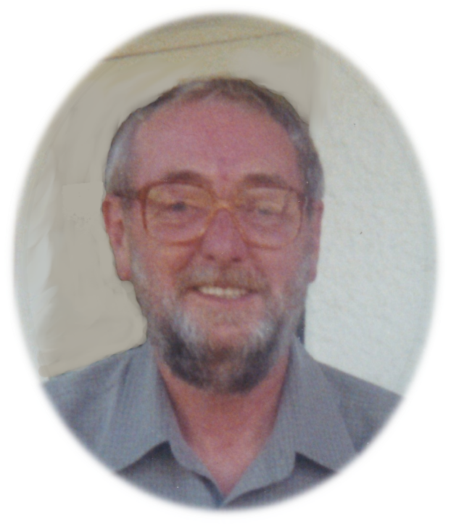

Born on 3rd June 1941, Roy grew up in Bradley with his mum and dad, Emily and Willy, his big sister, Kathleen, and his brothers, Leonard, Brian and Reuben. He was still only young when his mum sadly died, and he and Willy went to live with Kathleen and her husband, George. On finishing school at fifteen, Roy became an apprentice engineer at Whiteley’s, training as a fitter, before moving on to Seller’s Engineering, and then David Brown Gears. He worked in the parts department at David Brown’s Tractors as well, and as a maintenance engineer at a mill in Milnsbridge. Despite suffering the setback of redundancy, Roy was always determined to find work, and he finished his career back at David Brown’s, retiring from there at the age of 60.

Wherever he worked, Roy counted many friends amongst his colleagues. There was a real sense of community at David Brown’s, and Roy remained a regular drinking partner with his mates from Seller’s too, Barry, Jonathan and Tony, as well as meeting up with Barry and his family on holiday sometimes. Roy had family of his own by then, having met and married Brenda and become the proud father of his two boys, Darren and Jonathan.

They lived first in Netherton, then on Wormald Street in Almondbury. There was a field at the top of the road there, and Roy liked to join the boys for a kick about with the ball when he could. He had played football for Battyeford in his younger days, and was a keen supporter of Huddersfield Town, having gone to see them with his brother Brian as a lad. Roy took Darren and Jonathan to several Town matches, but more often on a Saturday they would be cheering on Almondbury United, on the touchline for every home game.

Roy loved sport of every variety; when a nurse in hospital asked him which sport he liked to watch, he said, ‘It’d be a shorter list if I told you the ones I don’t like!’ In terms of his own sporting career, cricket was his main passion; he played for Almondbury Wesleyans for a number of years as a fast bowler, and was delighted to see his enthusiasm passed on down the generations. Roy and Darren played together in one match as Roy was ending his cricketing career and Darren starting his, and when Roy’s grandson Harry took up the sport, Roy loved to go and watch him playing for Broad Oak and Golcar. Darren also played rugby at Waterloo through his teenage years, and again Roy was a staunch supporter in all weathers, taking him to games all over the north of England. In the same vein, he happily transported Darren and Jonathan all over for their various Scouting activities. When he did have a spare moment, Roy would escape to his allotment off Kaye Lane, though he always appreciated it when the boys came up and lent him a hand.

When Roy and Brenda divorced in 1981, Darren and Jonathan stayed living with Roy, and they would all muck in together with cooking and the like. The lads always got on well with their dad, and as adults would meet him for a pint at The Radcliffe Arms, or the ‘Top Shop’, where Roy was a regular, well-known and well-liked. Roy was good company, and even if he arrived at the pub alone, it wouldn’t be long before he found someone to talk to.

After a couple of years of single life, Roy met Peggy, their first date being the local Scout Dance at Almondbury School. They fell in love, marrying on 20th September 1986, and Roy became step-dad to Michael in the process. Roy and Peggy were so well-suited, and though they didn’t share all of each other’s interests, they supported each other in everything they did. They both enjoyed crown green bowling, Roy playing in the David Brown’s Workers League. And they also loved walking, from a stroll round Newmillerdam to weekends away in Grassington or the Lake District. Those trips to the Lakes were often taken with Pam and Trevor, Roy and Peggy’s neighbours and very good friends, and Darren and Jonathan sometimes came along too, Jonathan doing a good impression of a Scout leader as he marched them up the hills.

Roy and Peggy enjoyed their holidays; the east coast was always a favourite, particularly around Whitby, though when Darren and Jonathan were small it had been coach trips to Scarborough that formed the basis of their summer holidays. When Roy invested in the family’s first car, a Ford Anglia, they would all pile in, along with Tina the dog, and head down to Cornwall or Devon. Roy always did love to go for a drive out, him and Peggy often setting off for the day, equipped with flask and sandwiches. They also explored further afield, having some wonderful holidays in Mallorca and Cyprus, and had a fabulous trip to Malta along with the Honley Male Voice Choir.

Roy was a member of the choir for 21 years, and he loved every moment: the music itself and the friendships he made through it. He sang with the choir at Wembley, at Twickenham, and as part of the Night of 1000 Voices at the Albert Hall, and was amongst those crowned National Champions one year, as well as singing overseas on tours to the Netherlands as well as that trip to Malta.

Roy was always passionate about music; Darren and Jonathan remember him buying the first record box for the family in 1973, and he always encouraged them to play whatever instrument took their fancy, though they confess he hasn’t passed on the singing gene to either of them! But Roy did greatly enjoy seeing both boys play in various bands on the trumpet and other brass intruments. Even when he was just at a party or family gathering, Roy would often take the chance to play a bit of piano and have a sing-along, especially when his brother Leonard was there to join in. He was pretty good on the keyboard, and used to play the organ at Bradley Methodist Church. He and Peggy went to a lot of concerts at Huddersfield Town Hall, and Roy also enjoyed the jazz night at The King’s Head in town.

Roy welcomed his daughters-in-law, Maxine, Lynne and Susan, and was delighted to become a grandad to Danielle, Hannah, Jodie, Harry, Martin and Steven, and he was lucky enough to become a great-grandad too. He and Peggy helped to look after Jodie, Harry, Martin and Steven when they were small – they weren’t quite so fit when Danielle and Hannah came along, but they still loved seeing every one of them, and had a keen interest in what they, and the next generation, were all up to. Roy even mastered the art of WhatsApp, so he could communicate with Darren and his family over in New Zealand, mostly to share his views on the latest sport. He was certainly glued to his telly for every moment of the Cricket World Cup this summer, and was glad to see Huddersfield Town’s fortunes start to improve.

Darren is obviously here today, but the rest of Roy’s family over in New Zealand are very much here with us in spirit, and they have sent a few words for me to read on their behalf. Maxine put:

It is at times like this you are made acutely aware of how far away New Zealand is!

Sadly, we can’t be there to say to a much-loved father-in-law and grandad.

From the first time I met Roy he warmly welcomed me into the family. On mine and Darren’s wedding day he gave me a big hug and said I now have a daughter, and both he and Peggy always treated me like a daughter.

He has been a loving grandad, to Jodie and to Harry. He was always known as Grandad Furry Face by Harry when he was a little boy (because of his beard, in case you’re wondering).

Unfortunately, with moving to New Zealand, he has two great grandchildren he was never fortunate enough to meet, but we kept him up to date with photos and videos.

Despite being so many miles away, we’ve managed to spend some quality time with Roy on our visits to England in recent years. And no matter what suffering he was going through, he never seemed to lose his sense of humour, and always had a joke or a story to share.

Living so far away we felt guilty not being there, especially as Roy’s health started to deteriorate and he needed more help. Jonathan and Lynne bore the brunt of that. In particular, Darren has struggled with the fact he wasn’t able to do more for his dad.

So thank you, Jonathan, Lynne, Danielle and Hannah and Michael and Susan for everything you have done to look after Roy. We are sorry we couldn’t have helped more.

We were last in England in June and, when we said goodbye, I remember Roy saying with humour, “I’ll try and still be here next time you come home.”

We didn’t realise that was the final time we would see him.

Goodbye to a lovely dad and granddad – we’ll miss you!

Love Maxine, Harry and Jodie
Roy took great care of Peggy in her later years, as she did him; when things got too difficult to manage at the house in Almondbury, they moved to their flat in Newsome in 1995 and soon adopted their new local, The Fountain. All the family knew where to find Roy if he wasn’t in at home! This past year has been very hard for Roy, after losing Peggy, but his family have done all they can to help; Jonathan visited him pretty much every day, keeping him company and making sure he had everything he needed – Danielle was an able deputy when Jonathan couldn’t get there. Lynne, Michael and Susan all visited regularly to spend time with him and help out where they could. His neighbour Sarah kept an eye out for him and the odd time would stop and chat with him over a beer! Roy himself kept cheerful to the end, still having a joke with Hannah in his final days about her trip to the zoo. Roy was always a jovial soul, kind and friendly, with a smile and a good word for anyone he met. He was a loving dad, grandad and great-grandad, a great friend and a devoted husband, and he is sorely missed.

